Docker

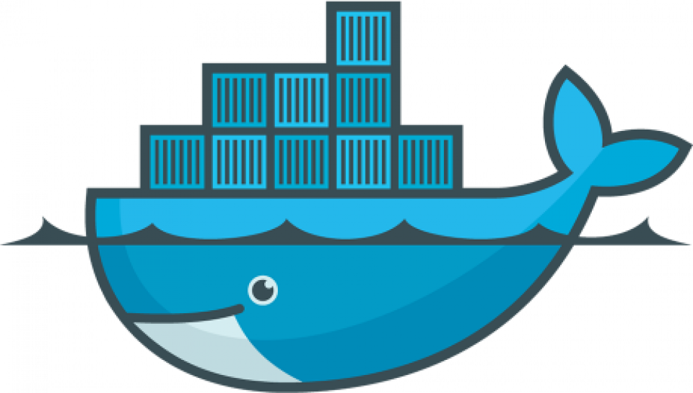

Table of Contents

Contents

Introduction 5

Why new technology? 5

What is Docker? 5

Advantages of Docker with Examples 6

Consistency across Environment 6

Portability 6

Isolation and Security 6

Scalability 7

Resource Efficiency 7

DevOps Enablement (Faster development and deployment) 7

Docker architecture 7

Docker Client 8

Docker Host 8

Docker Registry 8

Docker Objects 9

Docker daemon 9

Docker Engine 9

Docker Hub 9

Docker Compose 10

Docker Images 10

Docker Containers 11

Need for multiple containers of same image 11

DOCKER CLI – Port Mapping 12

Key Concepts in Port Mapping: 12

Common Use Cases for Port Mapping: 13

Docker – Container Lifecycle 15

Docker Desktop for Linux Vs Docker Engine 15

Installation 16

Pre-requisite 16

RPM Details 16

Installation using Utility 16

Manual Installation 17

Windows Installation - Desktop 19

Docker on windows using WSL2 & Ubuntu 22

Commands 29

docker version 29

docker info 29

systemctl commands 30

docker image 31

docker pull 31

docker run 32

docker rmi 33

docker inspect 33

docker ps 33

docker history 34

docker stop 34

docker top 34

docker stats 34

docker attach 34

docker pause 34

docker unpause 34

docker kill 34

Docker file 35

Dockerfile Instructions 35

Dockerizing Spring Boot Applications 37

Step1: Create SpringBoot application 37

Step 2: Create Dockerfile 38

Step 3: Build docker image 38

Step 4: Run docker image 39

Docker Desktop 40

Docker Image 41

Building Your First Docker Image 41

Prerequisites: 41

Steps: 41

Difference between Base Image and Parent Image 43

Code Examples 44

Key Points: 44

Tagging a Docker Image 44

Why Tags are Used: 45

Tagging a Docker Image: 45

Dockerizing on AWS 46

Important Links 47

# Introduction

Docker is a centralized platform for **packaging, deploying, and running applications.** Before Docker, many users face the problem that a particular code is running in the developer's system but not in the user's system. So, the main reason to develop docker is to help developers to **develop** applications easily, **ship** them into containers, and can be **deployed** & **run** anywhere.

One of the **biggest advantages of using docker is, we can containerize our application and it can be deployed on any platform like windows, linux etc.** For example, java application can be containerized using jre and there is no dependency on jdk env on machine, where we want to install.

## Why new technology?

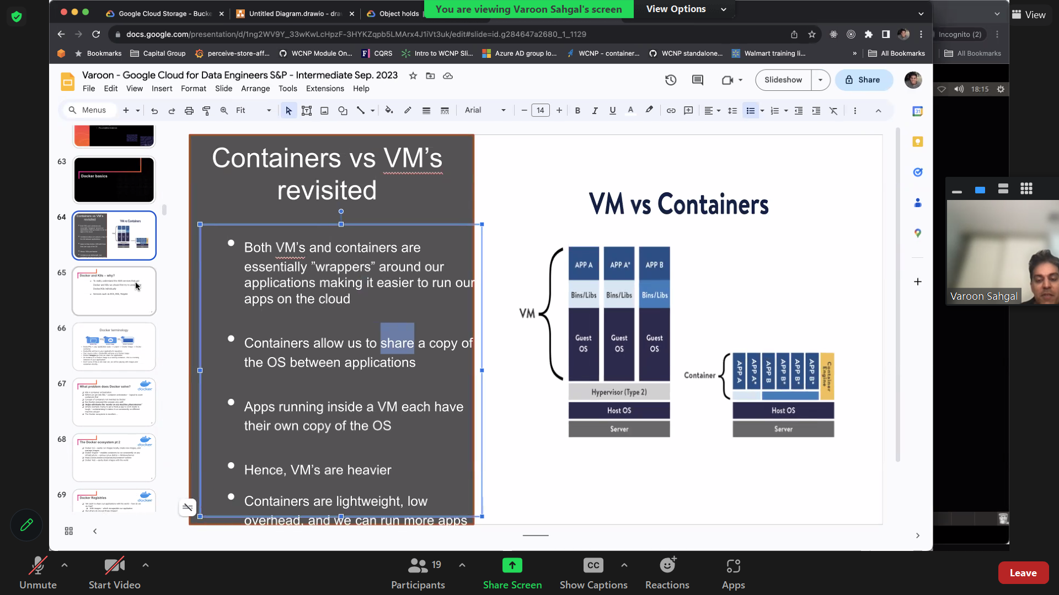

A **Virtual Machine** is a **software**that **emulates physical hardware** or a **computing system**. In simple terms, a **VM** allows many **separate computers** to run on the **hardware** of a **single computer**.

**VMs interact** with **physical computers** using **lightweight software layers** called **hypervisors**. **Hypervisors** separate **VMs** from one another and allocate **processors**, **memory**, and **storage** between them. A **VM** may also include necessary **system binaries** and **libraries** to run **applications**. The **host operating system (OS)** is managed and executed through the **hypervisor**.

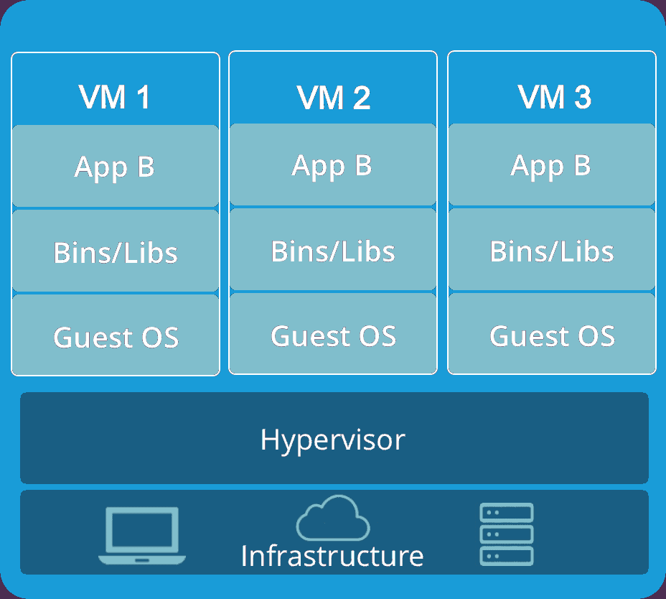

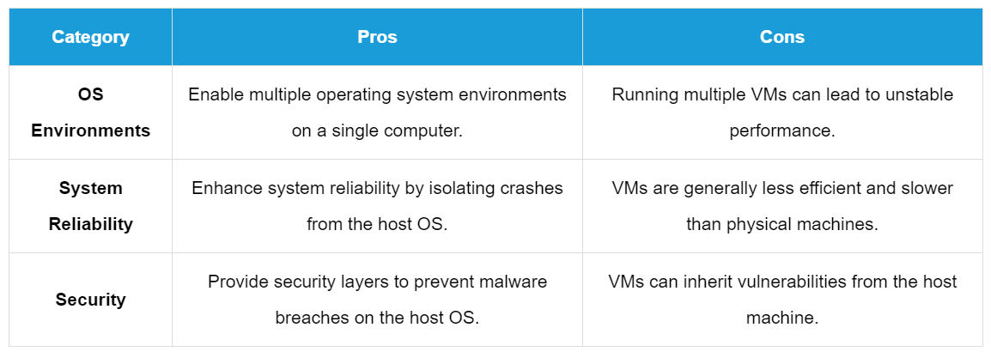

## What is Docker?

Docker is an **open-source centralized platform designed** to create, deploy, and run applications. Docker uses **container** on the host's operating system to run applications. It allows applications to use the same **Linux kernel** as a system on the host computer, rather than creating a whole virtual operating system. Containers ensure that our application works in any environment like development, test, or production.

### What Are Containers?

Containers are like **virtual compartments** that can run **software applications**. Imagine them as **small, self-contained boxes** that hold everything an **application needs to run smoothly**, like the **program itself** and **all the tools it requires**.

Before containers became popular, **Virtual Machines (VMs)** were used. These were like **complete computers within a computer**, each running its **operating system**. While **VMs** are still important, **containers** are now widely used because they are much **lighter and faster**.

### How Do Containers Work?

Containers need an **operating system**, along with **supporting software** and **resources**, to run a specific program. Inside a container, you can set up an **environment template** that ensures your **application behaves consistently** every time it runs.

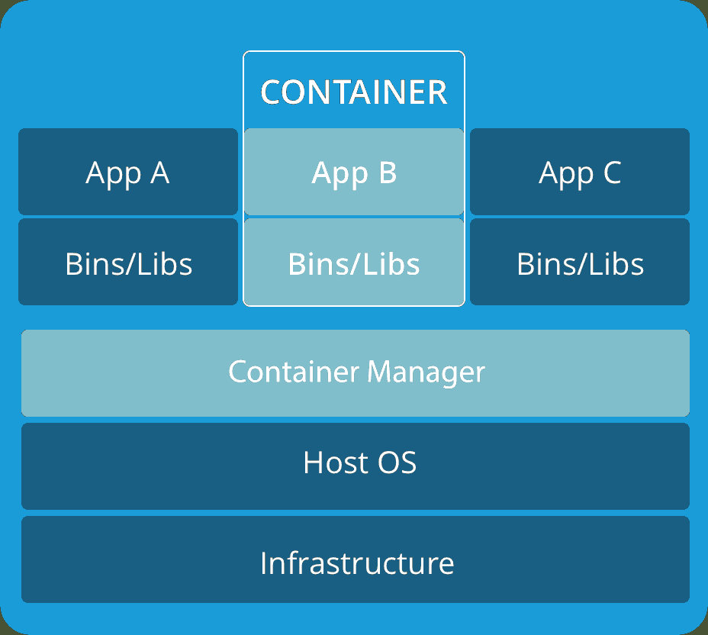

Containers **share the main operating system** (called the “kernel”) of the computer they are on. Each container only needs the **essential tools** and **libraries** to function.

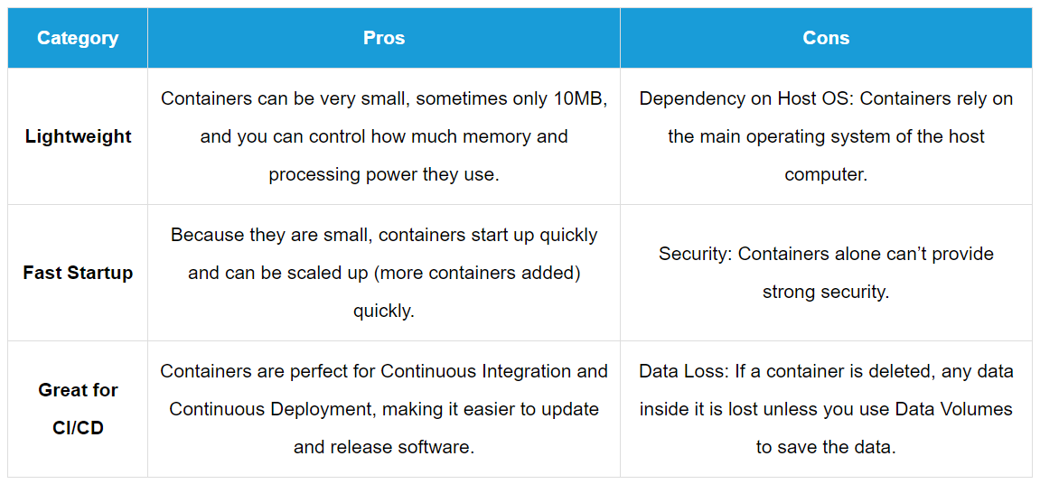

### Containers (Docker) vs Virtual Machines (VM)

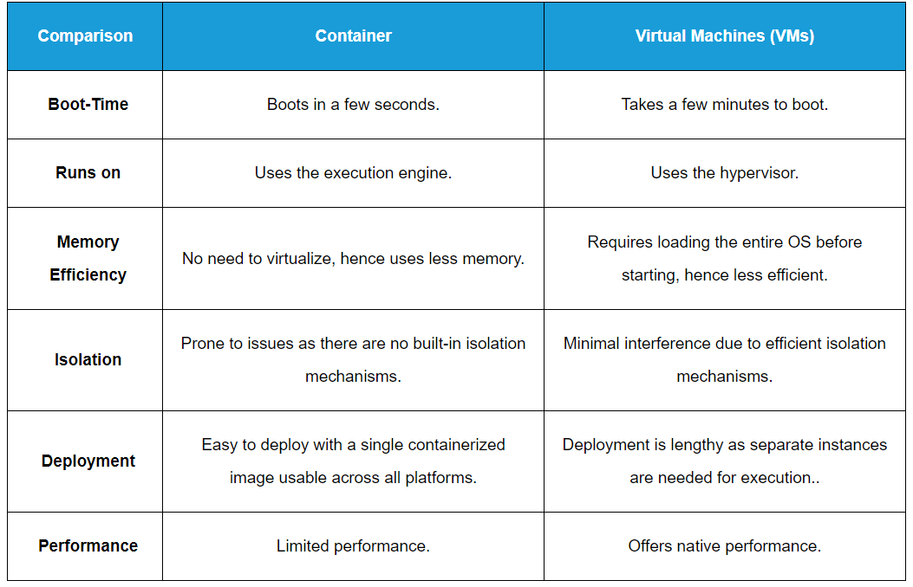

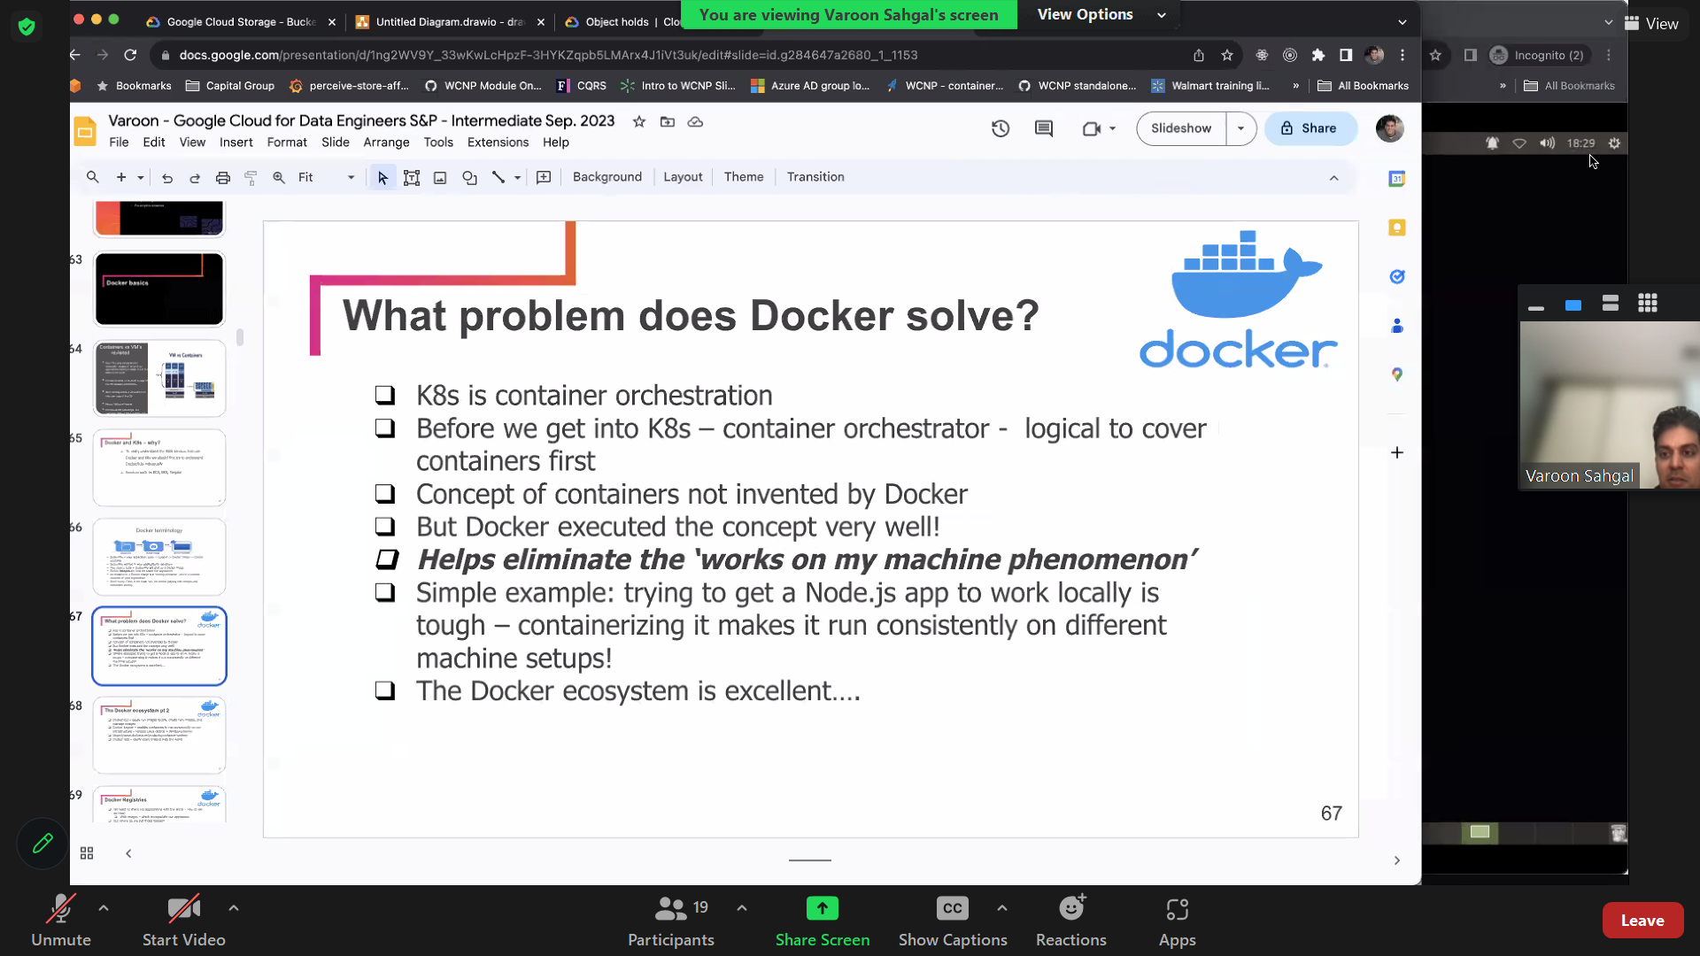

# Advantages of Docker with Examples

## Consistency across Environment

It ensures our application runs the same way everywhere, reducing the "it works on my machine" problem. Developers can share the exact environment configuration using Docker images, leading to fewer deployment issues and faster on boarding of new team members.

**Example:** Imagine we're developing a web application using Node.js. With Docker, we can package our Node.js application along with its dependencies (like specific Node.js version, npm packages, and configuration files) into a Docker image. This image can then be used consistently across different environments — development, testing, and production.

## Portability

Docker packages an application and its dependencies into a single unit, a container. This container can then run on any system with Docker installed, regardless of the underlying operating system (Windows, Mac, Linux).

Docker images are **platform-agnostic** and can run on any infrastructure that supports Docker. This portability makes it easier to move applications between environments, whether it's from a developer's laptop to a testing environment or from an on-premises data center to the cloud

**Example:** If we want to deploy any application to a cloud provider such as AWS or GCP. With Docker, we can build our application as a Docker image locally and then push this image to a Docker registry (like Docker Hub or a private registry). From there, we can pull the same image onto any server or cloud instance and run it without worrying about compatibility issues.

## Isolation and Security

Docker containers ensures that applications and their dependencies are encapsulated and do not interfere with each other. This enhances security by limiting the impact of potential vulnerabilities or misconfigurations within one component.

**Example**: - We can have multiple independent containers for MongoDB instances which will not impact each other’s configuration.

## Scalability

Docker containers are lightweight and start quickly, enabling rapid scaling based on demand. Container orchestration tools like Kubernetes can automate scaling based on metrics like CPU usage or incoming requests, ensuring your application can handle varying workloads efficiently.

**Example:** Suppose your application experiences increased traffic during peak hours. Docker makes it easy to scale our application horizontally by spinning up multiple instances (containers) of the same Docker image across multiple servers or cloud instances.

## Resource Efficiency

Unlike traditional virtual machines, which require a full guest operating system, Docker containers share the host kernel. This makes them lightweight and faster to start up and use fewer resources.

**Example:** A web server can be packaged as a Docker container. Running multiple web servers in containers on a single machine is more efficient than running them as separate virtual machines, saving on hardware costs.

## DevOps Enablement (Faster development and deployment)

Docker accelerates the development-to-production cycle by providing a consistent environment for building, testing, and deploying applications. This promotes continuous integration and continuous deployment (CI/CD) practices, leading to faster delivery of software updates and improvements.

**Example: - If we want to setup Jenkins servers, there are multiple pre-requisite like Java, tomcat, Maven etc. Also there are multiple version of Java available like 11,17 or 21. Similarly multiple versions exists for tomcat and Maven. Also some version of software may not be compatible with other software. Docker can make it easier to install Jenkins, taking care of all intricacies.**

# Docker architecture

Docker follows Client-Server architecture, which includes the three main components that are **Docker Client**, **Docker Host**, and **Docker Registry**.

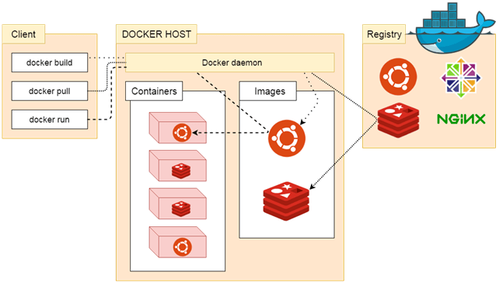

## Docker Client

Docker client uses commands and REST APIs to communicate with the **Docker Daemon** (Server). When a client runs any docker command on the docker client terminal, the client terminal sends these docker commands to the Docker daemon. Docker daemon receives these commands from the docker client in the form of command and REST API's request.

Docker Client uses Command Line Interface (CLI) to run the following commands -

* docker build
* docker pull
* docker run

The Docker CLI is a client tool and does not necessarily have to be on the same host as the rest of the other components. It can be on a remote system such as a laptop and still communicate with a remote Docker engine.

To communicate with a remote Docker engine by using Docker CLI, pass the -H flag followed by an IP address of the remote host and a port number as shown in the syntax below:

docker -H=remote-host-ip:port-number

For example, to run an Apache container on a remote Docker engine whose IP is 10.10.2.1, run the following command:

docker -H=10.10.2.1:2375 run httpd

## Docker Host

Docker Host is used to provide an environment to execute and run applications. It contains the docker *daemon, images, containers, networks, and storage.*

The Docker host refers to the physical or virtual machine on which Docker Engine is installed and running. It's the underlying operating system environment where Docker containers are deployed and managed.

**Responsibilities**:

* **Host Operating System**: Provides the foundational operating system environment (e.g., Linux, Windows) where Docker containers run.
* **Docker Engine Installation**: Hosts the Docker Engine (dockerd), which manages containerized applications, images, networks, and volumes.
* **Resource Management**: Allocates CPU, memory, storage, and network resources to Docker containers running on the host.

**Usage**: Developers and operators deploy Docker containers on Docker hosts, leveraging Docker Engine's capabilities to create isolated and portable application environments.

## Docker Registry

Docker Registry manages and stores the Docker images. There are 2 types of registries

* Public Registry – also called Docker Hub
* Private Registry - used to share images within the enterprise

New generation of **virtualization**, enabled through Docker.

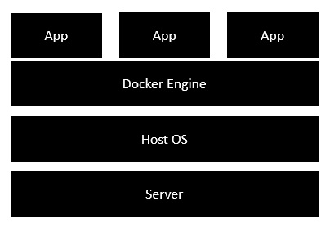

# Docker Objects

## Docker daemon

Docker daemon runs on the host operating system. It is responsible for running containers to manage docker services. Docker daemon communicates with other daemons. It offers various Docker objects such as ***images, containers, networking, and storage***.

## Docker Engine

It is used for building Docker images and creating Docker containers.

**Docker Engine is essentially Docker installed on a host.** When you install Docker on a system, you are installing the following key components: the Docker daemon, Docker REST API, and Docker CLI which interacts with the Docker daemon through the REST API.

**Components of Docker Engine**

* **Docker Daemon (dockerd):** A long-running process that listens for Docker API requests and manages Docker objects such as images, containers, networks, and volumes.
* **Docker Client (docker):** A command-line interface (CLI) client that interacts with the Docker daemon. Most Docker commands are executed through this client.
* **Docker Registry:** A storage repository for Docker images. Docker Hub is a popular public registry.

## Docker Hub

Docker Hub is a **public registry service** on the cloud, that allows you to download Docker images that are built by other communities. We can also upload our own Docker built images to Docker hub.

<https://hub.docker.com/>

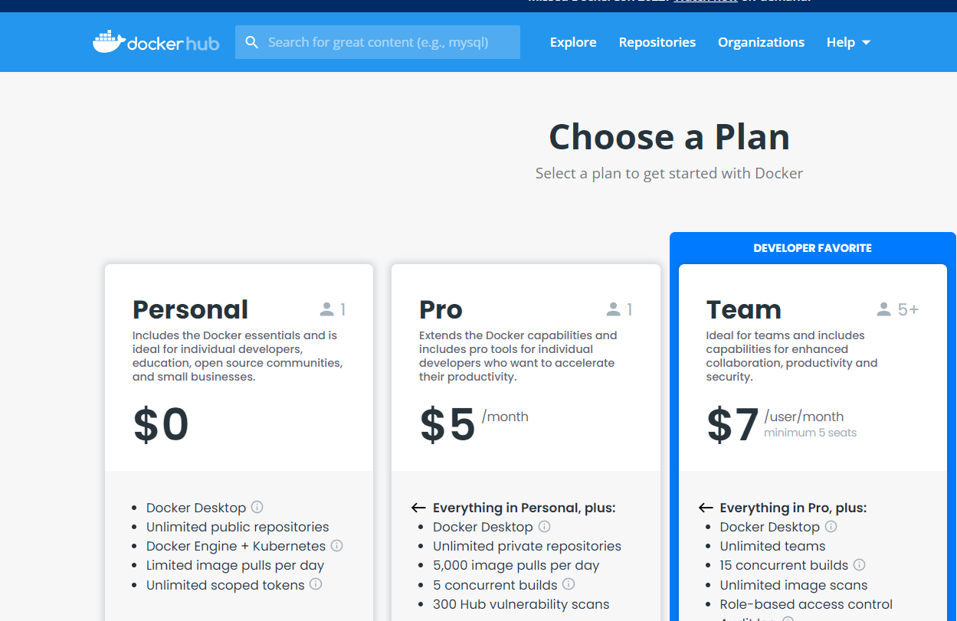

**Example of hello-world image at docker hub**

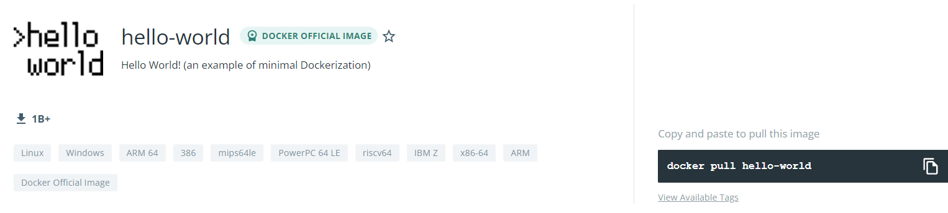

## Docker Compose

This is used to define applications using multiple Docker containers

## Docker Images

Docker images are the **read-only binary templates** used to create Docker Containers. It uses a private container registry to share container images within the enterprise and uses public container registry to share container images within the whole world. Metadata is also used by docket images to describe the container's abilities.

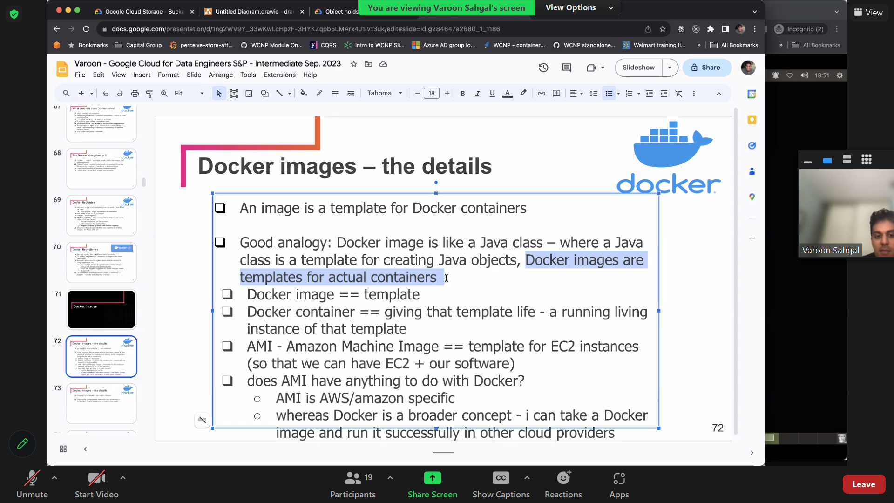

## Docker Containers

Docker containers are the **lightweight** **alternatives of the virtual machine.** It allows developers to package up the application with all its **libraries** and **dependencies** and ship it as a **single package.** The advantage of using a docker container is that you don't need to allocate any RAM and disk space for the applications. It automatically generates storage and space according to the application requirement. In short, **containers are instances of Docker images** that can be run using the **Docker run command.**

Containers are the structural units of Docker, which is **used to hold the entire package** that is needed to run the application. The advantage of containers is that it requires very less resources.

In other words, we can say that the **image is a template, and the container is a copy of that template.**

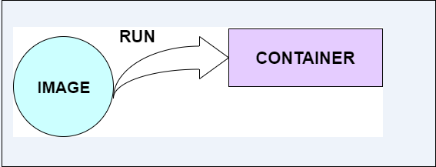

Below command can be used for listing of containers

$ docker ps

### Need for multiple containers of same image

For scaling up application, when workload is higher

## DOCKER CLI – Port Mapping

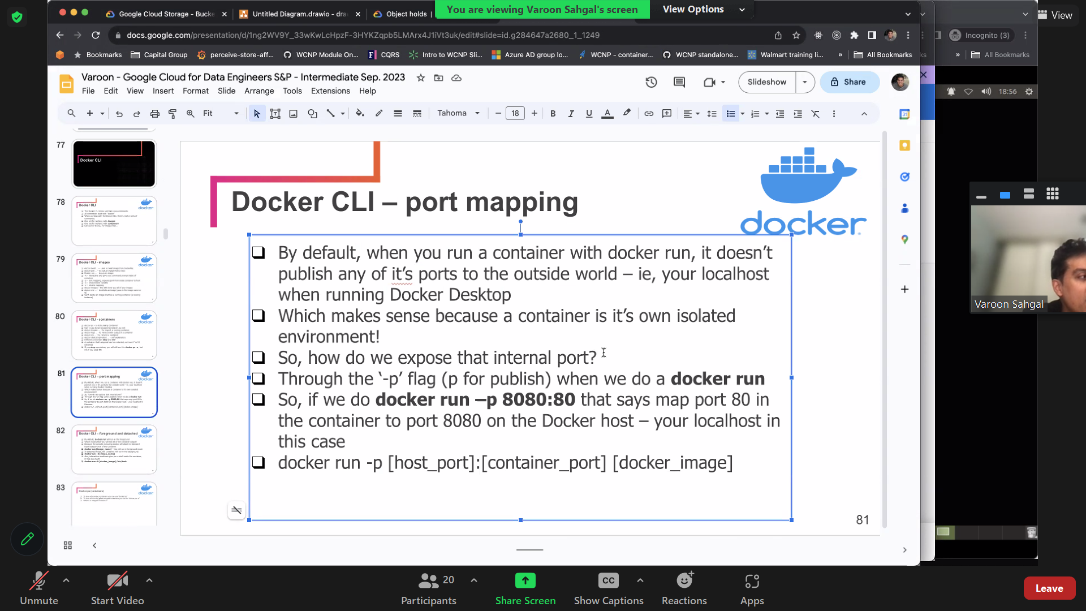

### Key Concepts in Port Mapping:

#### Port

Ports are numeric identifiers used to differentiate between different network services running on the same host. Ports are categorized into two groups: well-known ports (ranging from 0 to 1023) and dynamic or private ports (ranging from 1024 to 49151). Well-known ports are reserved for commonly used services like HTTP (port 80) and HTTPS (port 443).

#### Host Port vs. Container Port:

* **Host Port:** This is a port on the host system, which is the machine where Docker is running. The host port is used to access the service or application running inside the Docker container from the host machine or from external systems.
* **Container Port:** This is the port on which the service or application inside the Docker container is listening. It may be a specific port required by the application, for example, a web server listening on port 80.

#### Dynamic Mapping

If you omit the host_port, Docker will automatically assign an available host port. This is useful when you want to avoid port conflicts on the host system.

**docker run -d -p 8080 my-app**

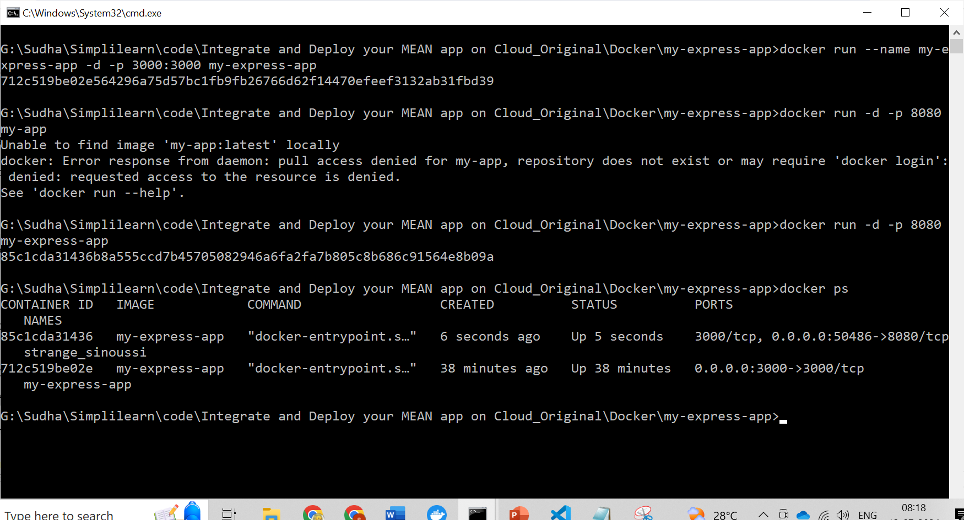

#### Difference between the -p and -P options in Docker:

**-p (or –publish):**

The -p (or –publish) option is used to explicitly specify port mappings when running a Docker container. It allows you to **map a specific port on the host system to a specific port inside the container.** The syntax for using -p is -p <host_port>:<container_port>.

**For Example:**  
1.  Deploy an nginx container by exposing its port to 8080.

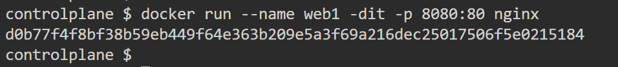

**-P (or –publish-all):**

The -P (or –publish-all) option is used to automatically publish all exposed ports defined in the Docker image to random ports on the host system. When you use -P, Docker assigns random available ports on the host for each exposed port in the container.

**For example:**  
1.  Deploy an nginx container by exposing its port to any random port using ‘-P’

$ docker run --name web2 -dit -P nginx

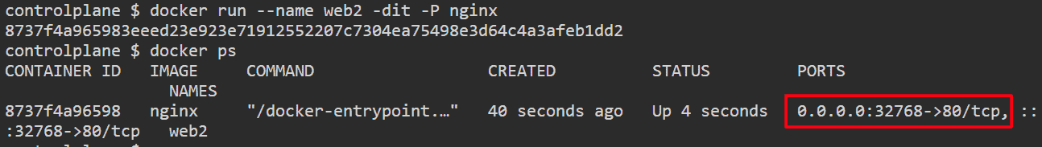

### Common Use Cases for Port Mapping:

* **Exposing Web Services:** Port mapping is frequently employed to expose web services running inside containers. This includes web servers like Nginx or Apache, or web applications. Port mapping allows users to access these services via a web browser.
* **Database Access:** Port mapping can be used to connect containers to database servers. This enables applications running in containers to interact with database services running outside of the containers.
* **Load Balancing:** Port mapping plays a role in load balancing strategies, where multiple containers providing the same service are mapped to the same host port. This ensures even distribution of incoming requests.

# Docker – Container Lifecycle

* Initially, the Docker container will be in the **created** state.
* Then the Docker container goes into the running state when the Docker **run** command is used.
* The Docker **kill** command is used to kill an existing Docker container.
* The Docker **pause** command is used to pause an existing Docker container.
* The Docker **stop** command is used to pause an existing Docker container.
* The Docker **run** command is used to put a container back from a **stopped** state to a **running** state.

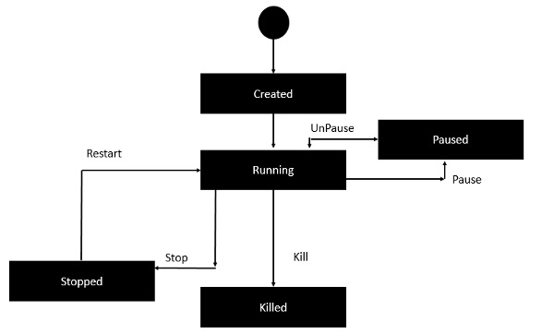

# Docker Desktop for Linux Vs Docker Engine

Docker Desktop is **primarily designed for Windows and macOS** operating systems, providing a user-friendly interface and tools to manage Docker containers and services. However, on Linux distributions, Docker Desktop is not available in the same form. **Instead, Linux users typically use Docker Engine directly.**

Docker Desktop for Linux and Docker Engine can be installed side-by-side on the same machine.

Docker Desktop for Linux **stores containers and images** in an isolated storage location within a VM and offers controls to restrict its resources. Using a dedicated storage location for Docker Desktop prevents it from interfering with a Docker Engine installation on the same machine.

While it’s possible to run both Docker Desktop and Docker Engine simultaneously, there may be situations where running both at the same time can cause issues. For example, when mapping network ports (-p / --publish) for containers, both Docker Desktop and Docker Engine may attempt to reserve the same port on your machine, which can lead to conflicts (“port already in use”).

**We generally recommend stopping the Docker Engine while you’re using Docker Desktop to prevent the Docker Engine from consuming resources** and to prevent conflicts as described above.

Use the following command to **stop the Docker Engine** service:

$ sudo systemctl stop docker docker.socket containerd

Depending on your installation, the Docker Engine may be configured to automatically start as a system service when your machine starts. Use the following command to **disable the Docker Engine service,** and to prevent it from starting automatically:

$ sudo systemctl disable docker docker.socket containerd

# Installation

## Pre-requisite

Docker need two important installation requirements:

* It only works on a 64-bit Linux installation.
* It requires **Linux** **kernel version 3.10** or higher.

To check your current kernel version, open a terminal and type ***uname -r*** command to display your kernel version:



## RPM Details

**Docker Compose**

Docker Compose is a tool that was developed to help **define and share multi-container applications**. With Compose, we **can create a YAML** file to define the services and with a single command, can spin everything up or tear it all down.

For manually installing from <https://download.docker.com/linux/centos/7/x86_64/stable/Packages/>

[**docker-compose-plugin**-2.6.0-3.el7.x86_64.rpm](https://download.docker.com/linux/centos/7/x86_64/stable/Packages/docker-compose-plugin-2.6.0-3.el7.x86_64.rpm)

$ docker-compose version

## Installation using Utility

yum install -y yum-utils

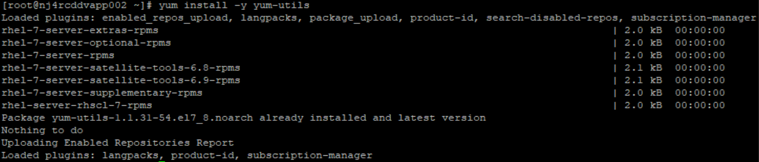

sudo yum-config-manager \

--add-repo \

https://download.docker.com/linux/centos/docker-ce.repo

sudo yum-config-manager --add-repo https://download.docker.com/linux/centos/docker-ce.repo

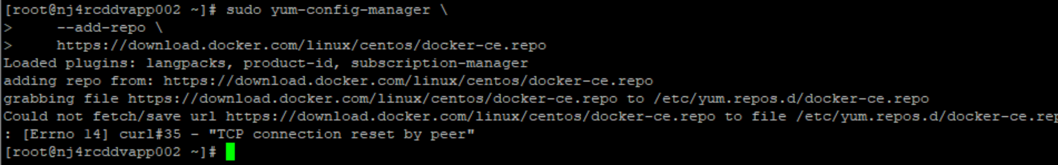

In above case, it failed and hence we can try installing it manually

## Manual Installation

To find version of CentOs

view /etc/os-release

<https://docs.docker.com/engine/install/centos/#install-from-a-package>

[root@ XXXXX]# docker pull hello-world

Using default tag: latest

Error response from daemon: Get "https://registry-1.docker.io/v2/": read tcp 10.72.74.26:42452->44.194.5.25:443: read: connection reset by peer

Check your network connectivity with above <https://registry-1.docker.io/v2>

curl https://registry-1.docker.io/v2/ && echo Works || echo Problem

[root@xxxx]# curl https://registry-1.docker.io/v2/ && echo Works || echo Problem

curl: (35) TCP connection reset by peer

**Problem**

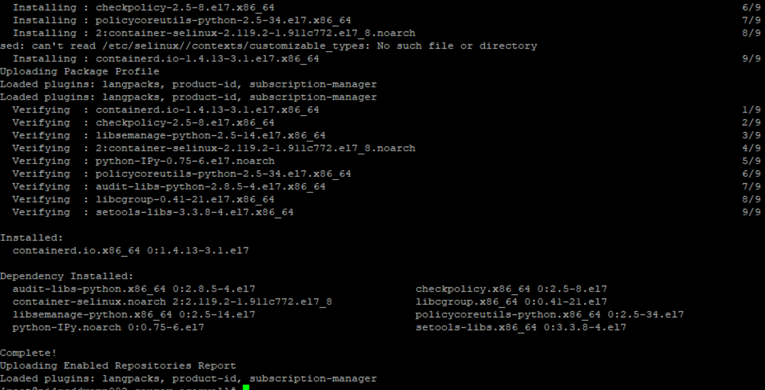

Copied following rpms from <https://download.docker.com/linux/centos/7/x86_64/stable/Packages/>

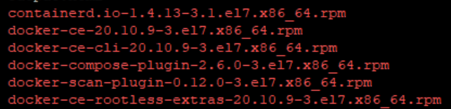

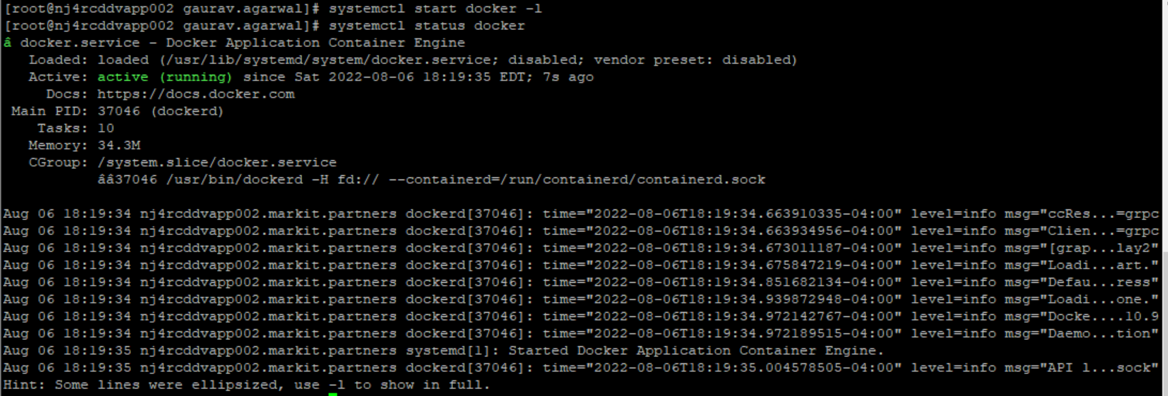

Uninstall

yum remove docker-ce docker-ce-cli docker-ce-rootless-extras containerd.io docker-compose-plugin docker-scan-plugin

## Windows Installation - Desktop

Download “**Docker Desktop Installer.exe**” from below link or from Docker Hub

<https://docs.docker.com/desktop/install/windows-install/>

*Before installation, let’s learn about* ***WSL. Windows subsystem for Linux*** *is**compatibility layer provided by Microsoft in* ***Windows 10 and later versions that allows you to run native Linux command-line tools*** *and applications directly on Windows without needing a traditional virtual machine. We* can *install different Linux distributions (e.g., Ubuntu, Debian, CentOS) from the Microsoft Store or using command-line tools like wsl --install.*

When prompted, ensure the **Use WSL 2 instead of Hyper-V** option on the Configuration page is selected or not depending on your choice of backend.

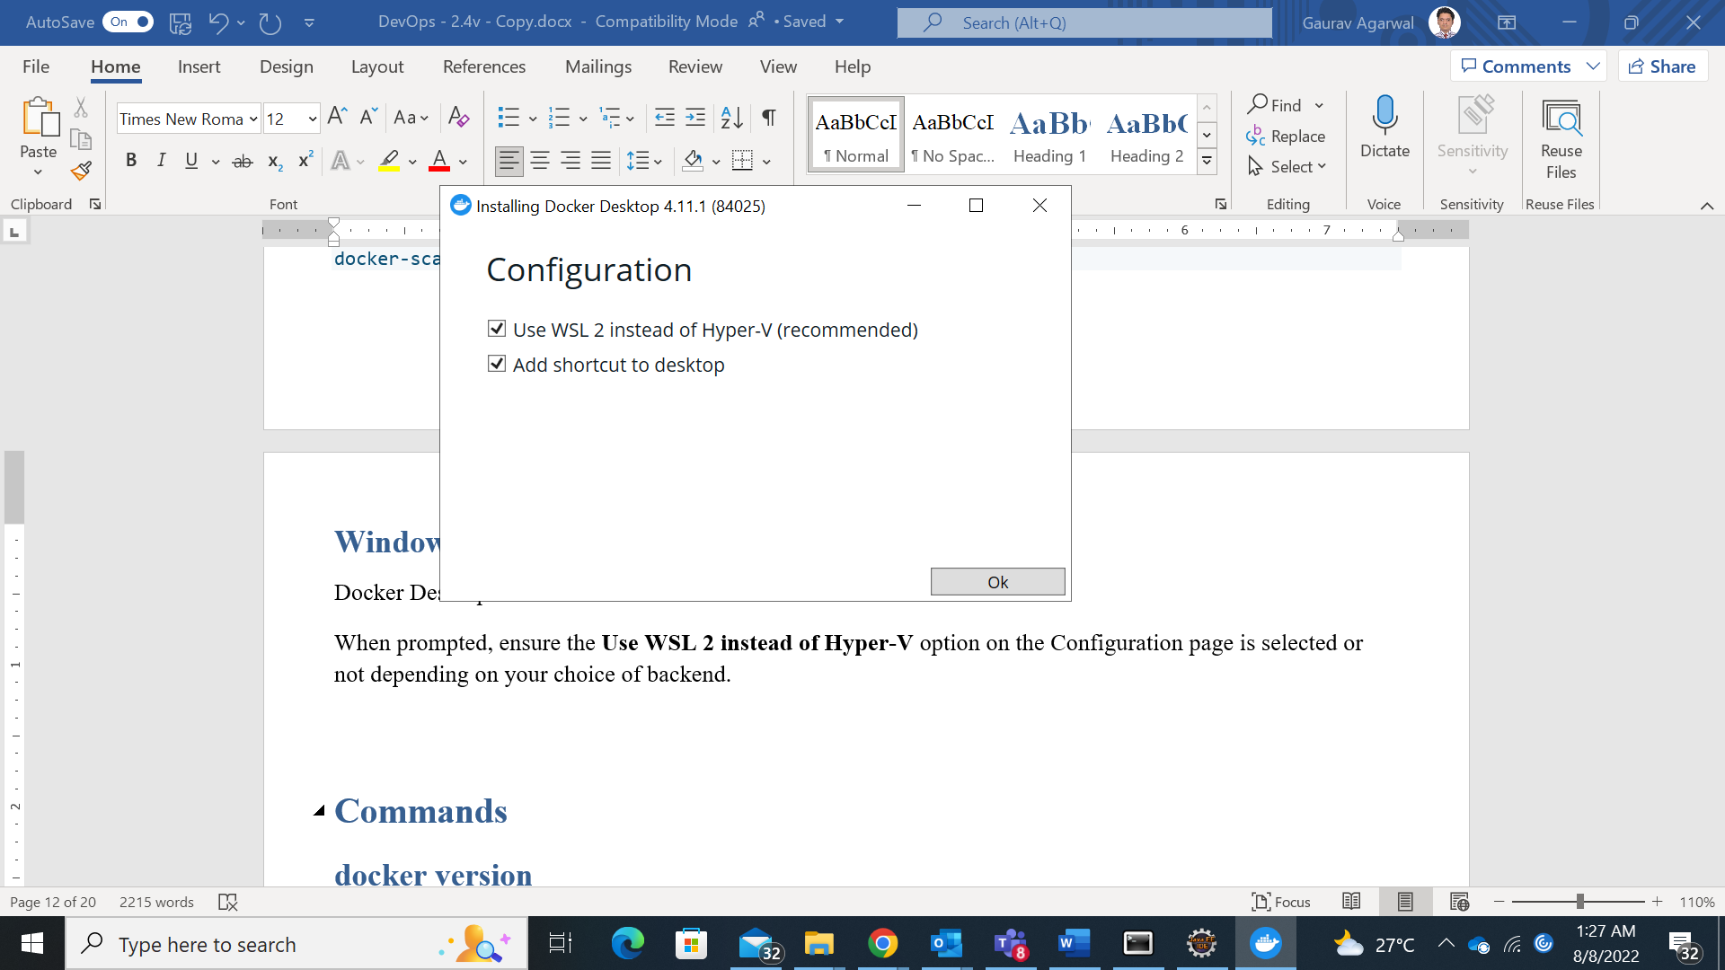

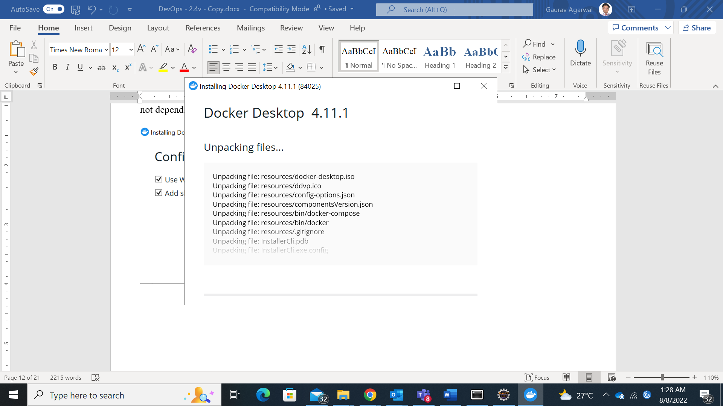

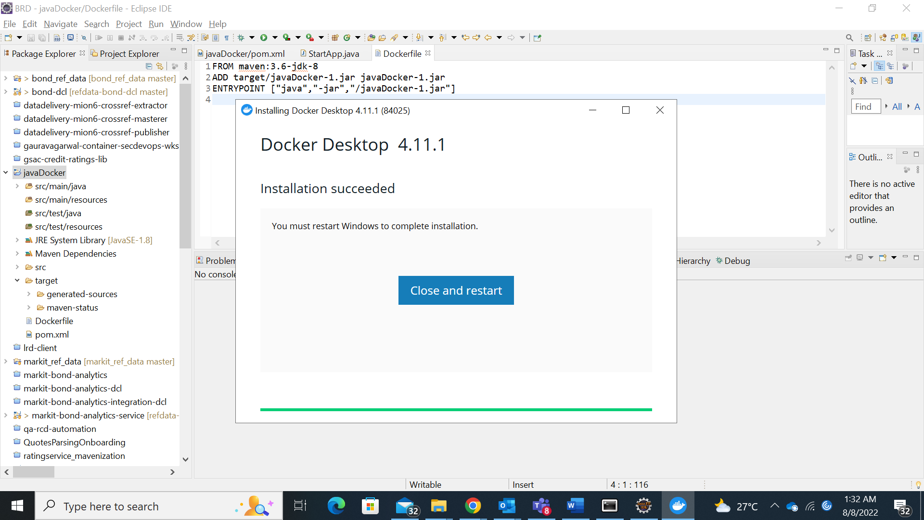

If your admin account is different to your user account, you must add the user to the **docker-users** group. Run **Computer Management** as an **administrator** and navigate to **Local Users and Groups** > **Groups** > **docker-users**. Right-click to add the user to the group. Log out and log back in for the changes to take effect.

**Test windows docker setup**

Docker Desktop does not start automatically after installation.

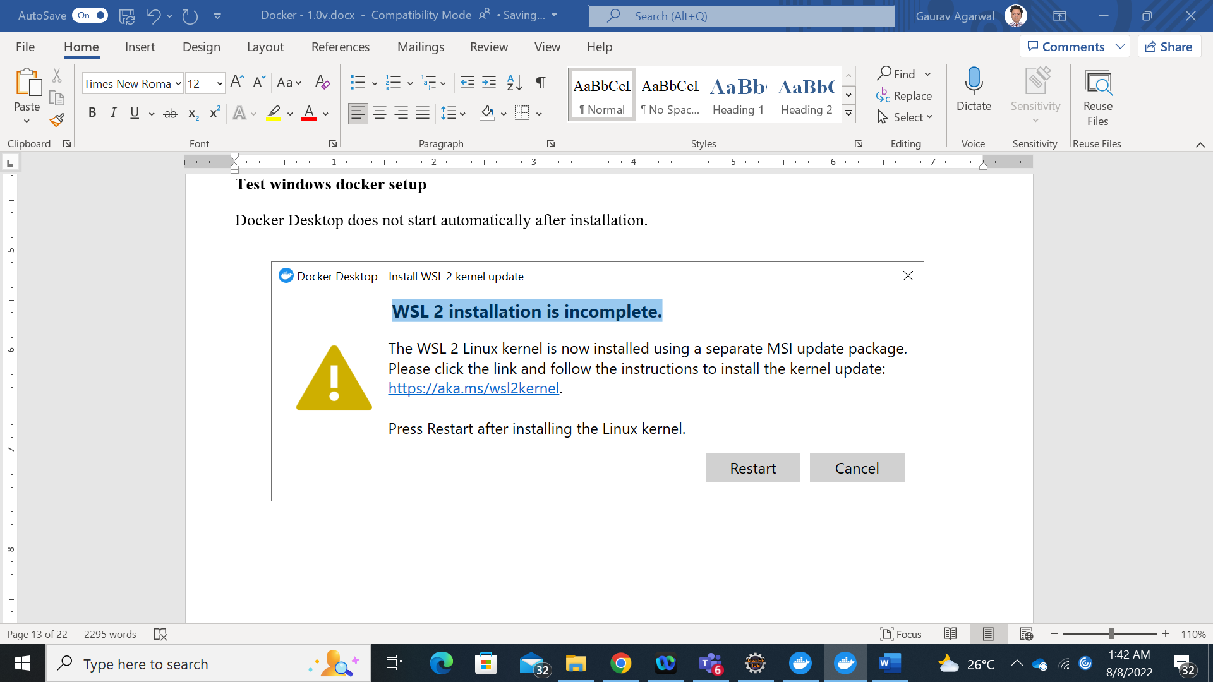

<https://docs.microsoft.com/en-us/windows/wsl/install-manual#step-4---download-the-linux-kernel-update-package>

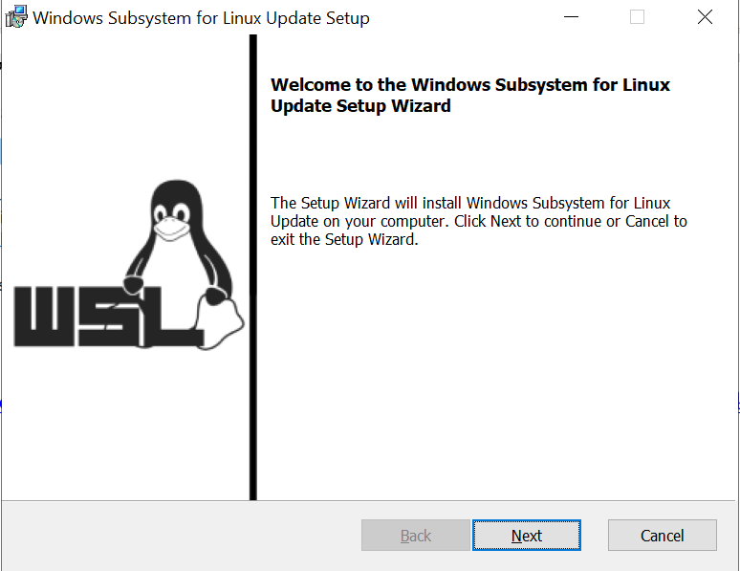

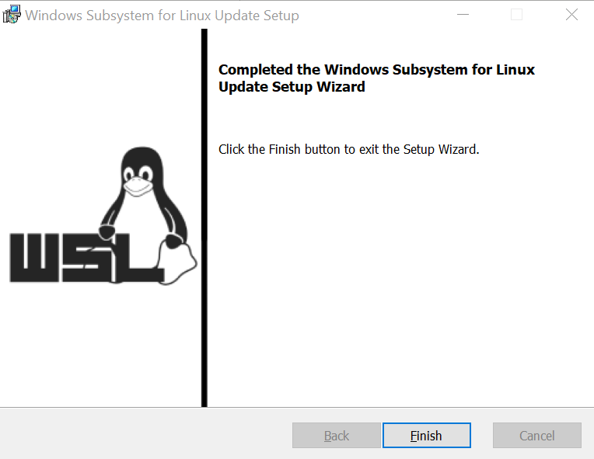

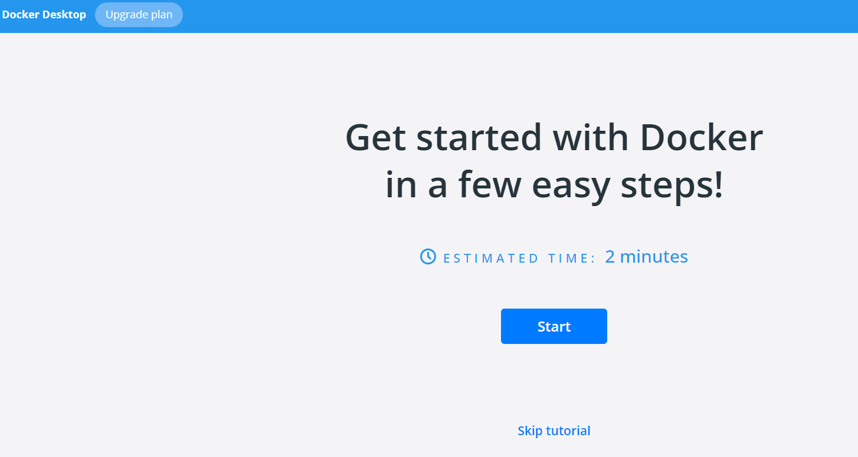

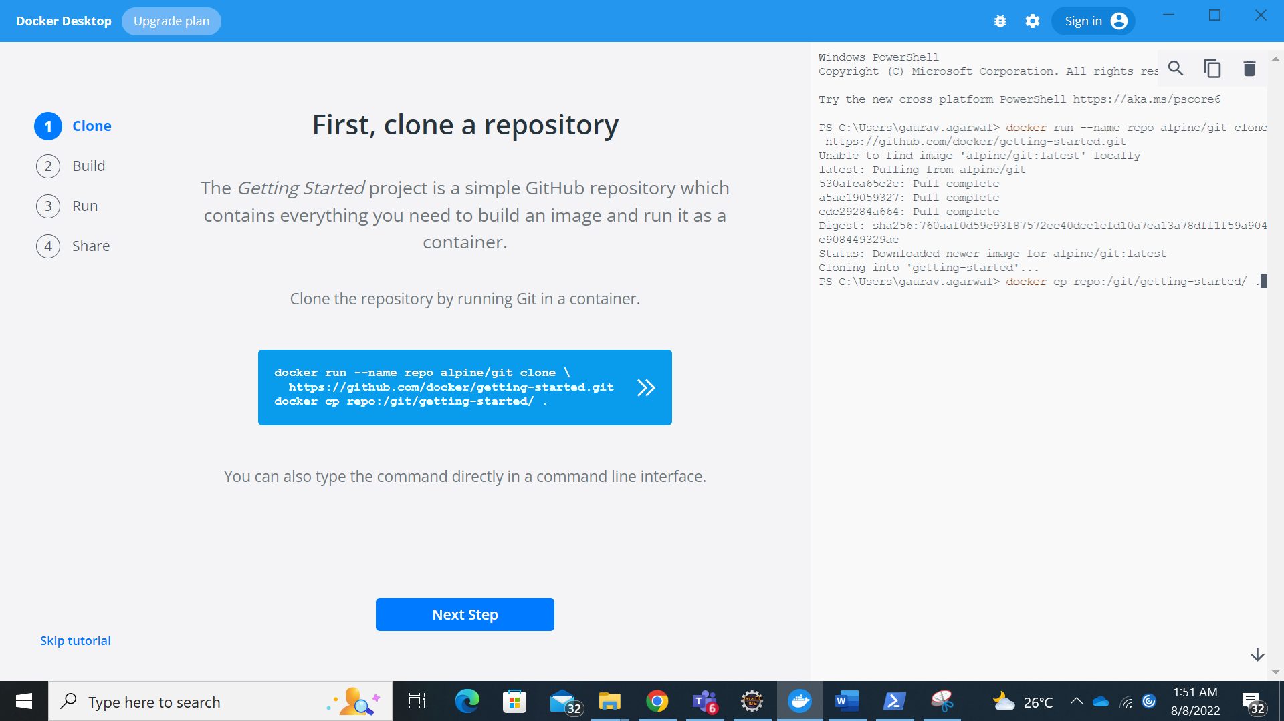

## Docker on windows using WSL2 & Ubuntu

Prerequisite’s

1. **Uninstall Docker Desktop**

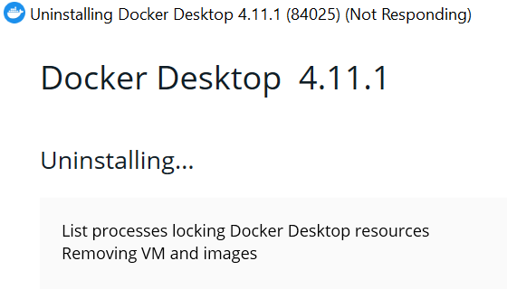

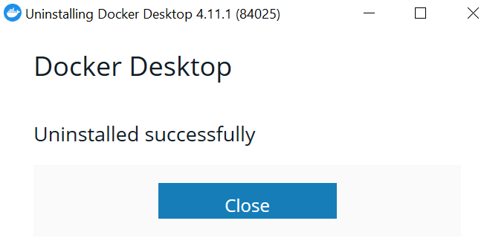

If Docker desktop is not removed, following will be displayed in powershell (wsl –list –verbose)

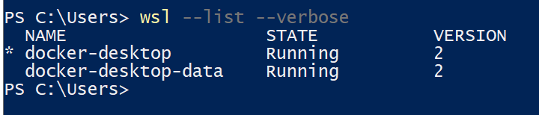

1. Install WSL2 (we should have already)
2. Install **“Ubuntu 20.04 LTS”** or latest “Ubuntu 22.04 LTS” distribution

*Note: - Try using* ***Ubuntu 20.04 LTS*** *as we faced issue with latest version of Ubuntu 22.04 LTS*

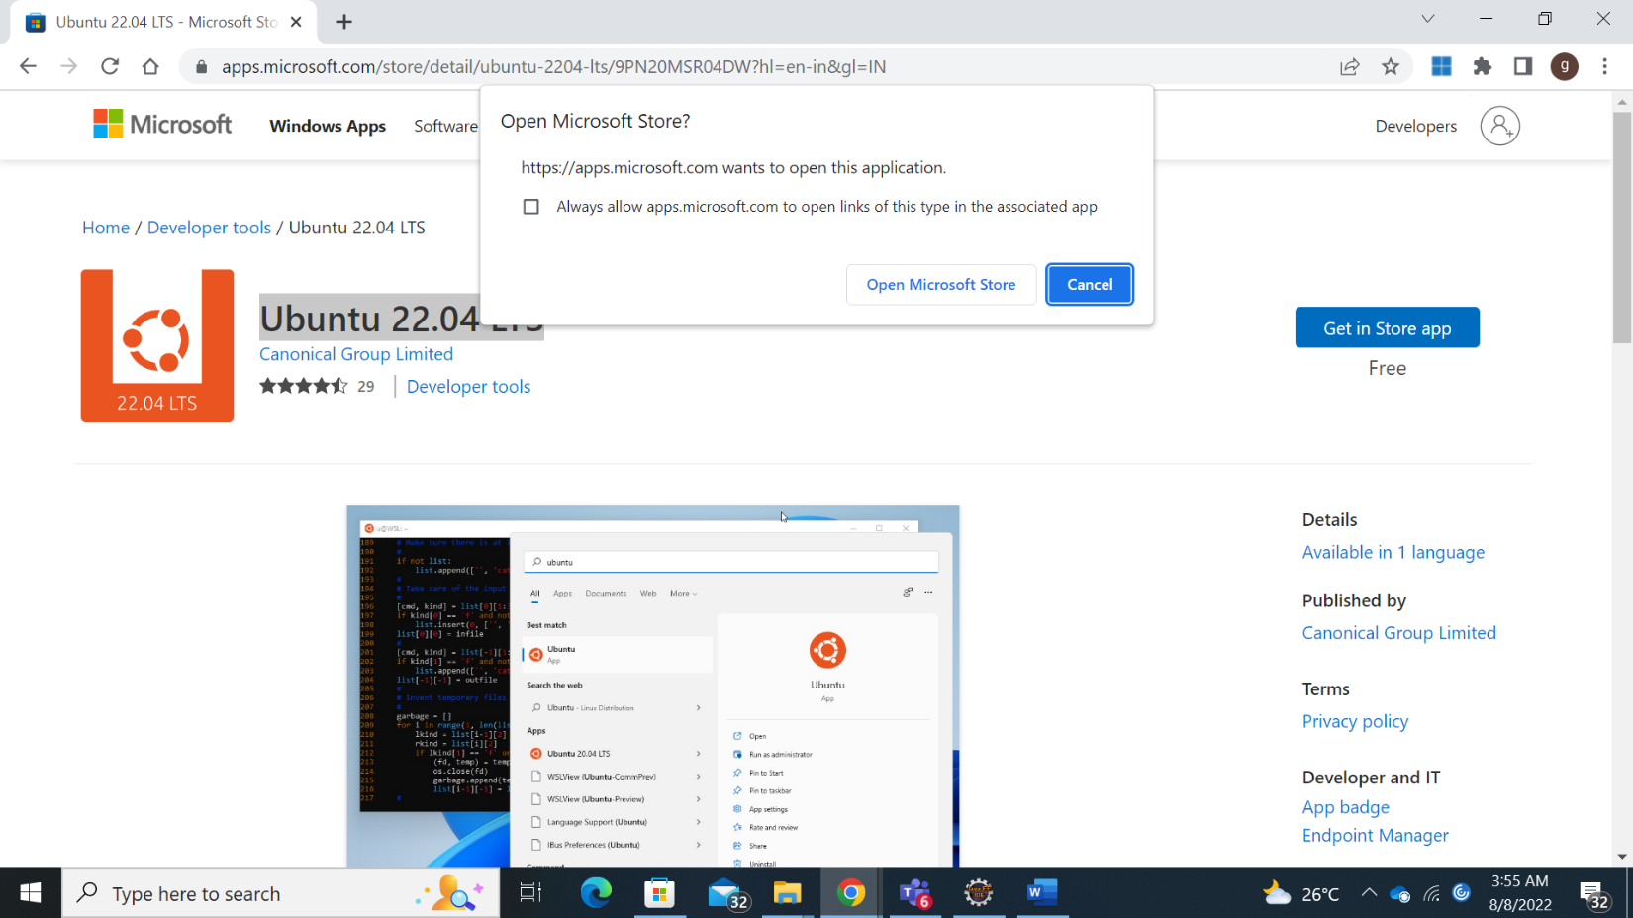

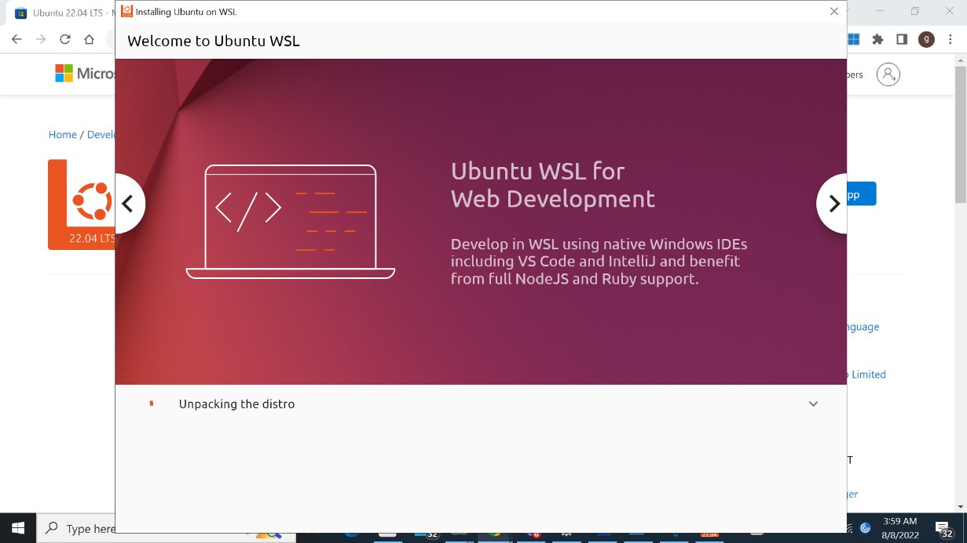

Run wsl --list --verbose to make sure you have Ubuntu running in WSL2

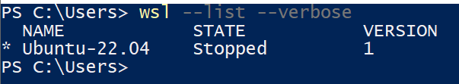

If ubuntu is not running, start from windows

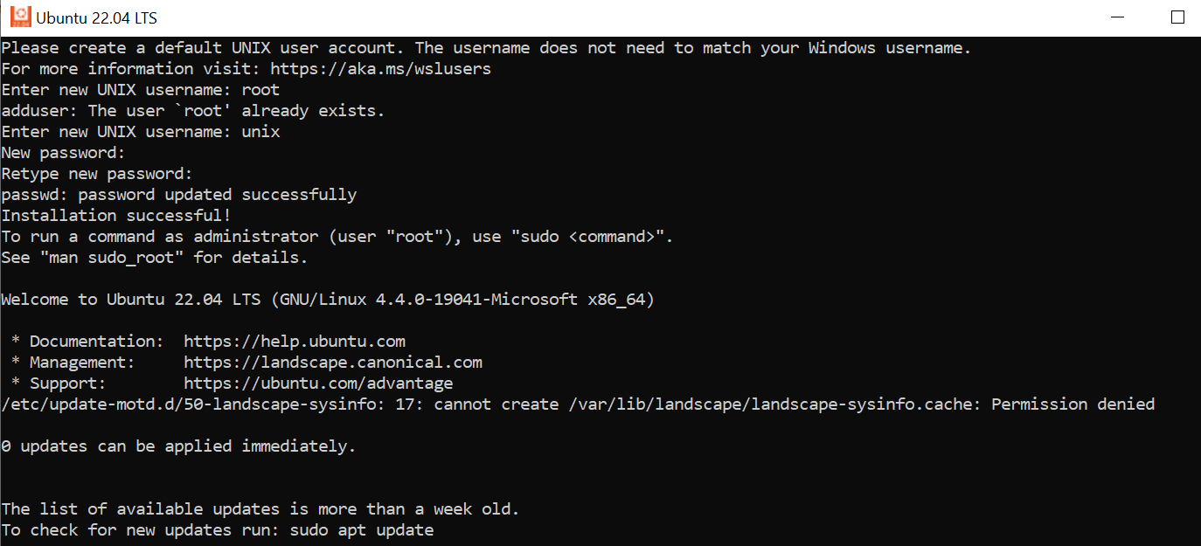

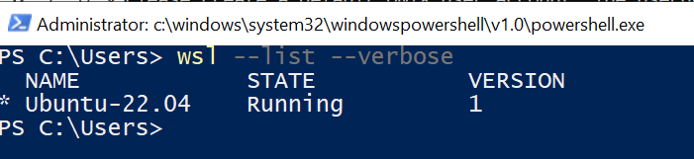

1. Update and Upgrade Ubuntu
   1. sudo apt **update**

Above command is used to download package information from all configured sources. So, when we run update command, it downloads the package information from the Internet. But above command will not install these updates.

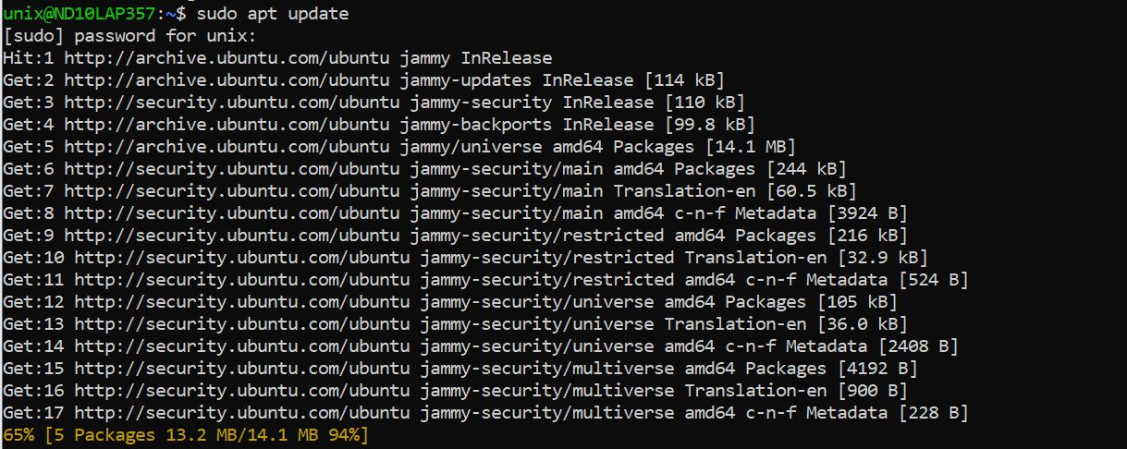

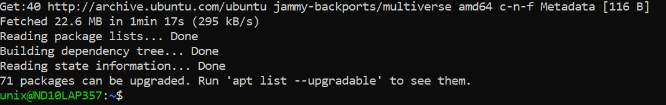

* 1. sudo apt **upgrade**

As shown above, **apt update** command gets an updated list of packages from the Internet. Now same can be installed using **apt upgrade** command. This is useful in installing latest version.

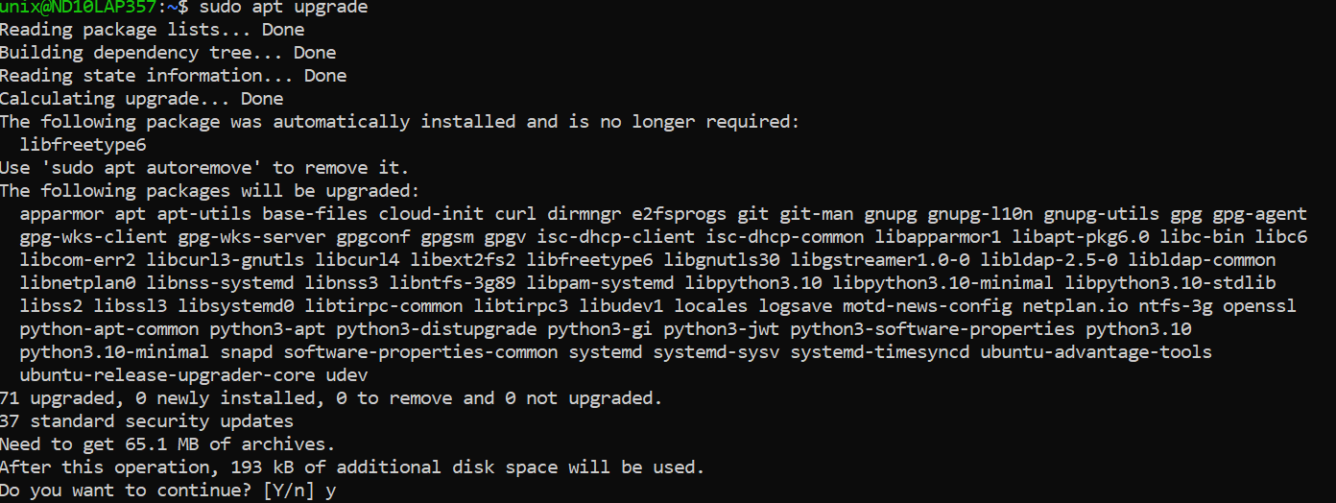

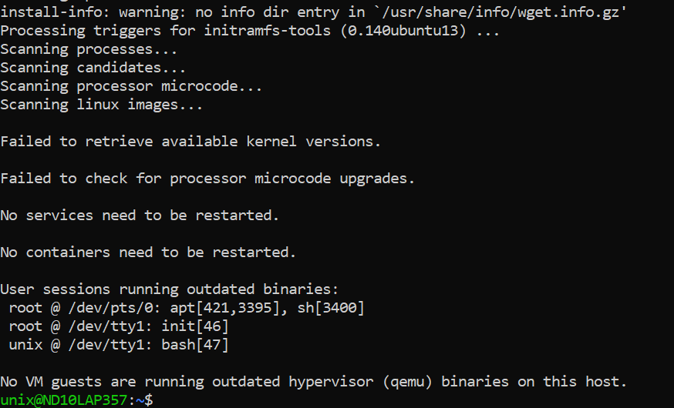

1. **Install Curl command**
   1. Run curl if it outputs the following below then skip this section otherwise run 5.b

 sudo apt install curl

* 1. Run sudo apt install curl

1. **Install Docker** using following command
   1. sudo apt install docker.io -y

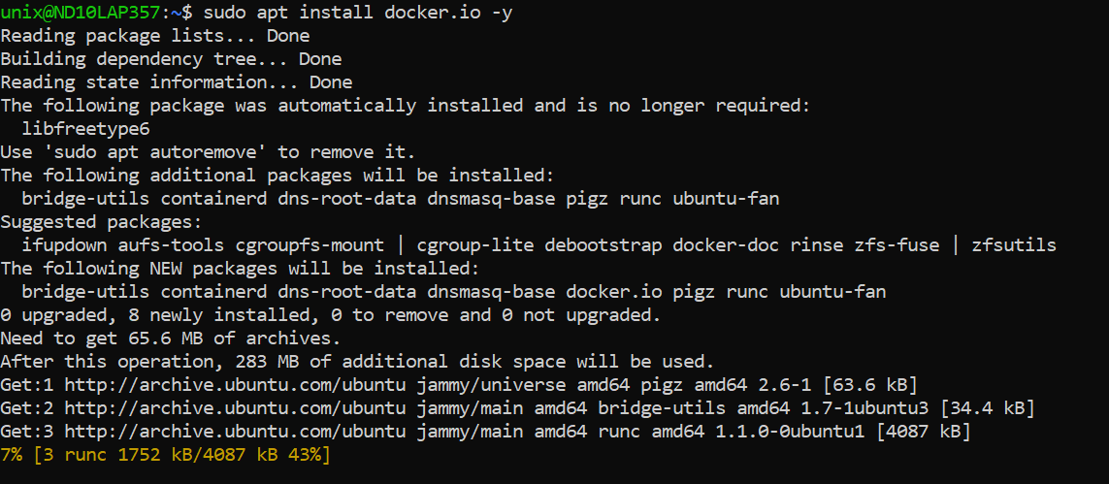

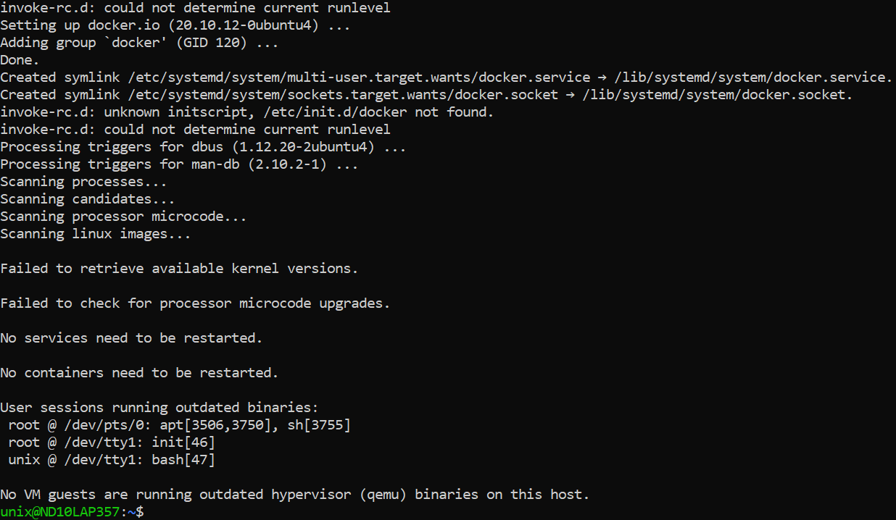

* 1. Check the version docker ––version

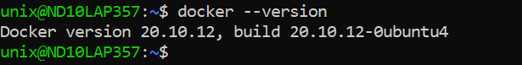

1. **Install Docker-Compose** sudo curl -L "https://github.com/docker/compose/releases/download/1.29.2/docker-compose-$(uname -s)-$(uname -m)" -o /usr/local/bin/docker-compose

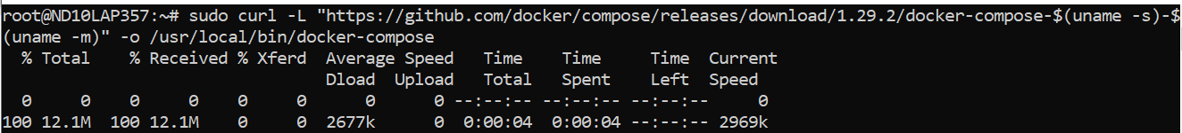

* 1. Change file permission sudo chmod +x /usr/local/bin/docker-compose
  2. Check the version sudo docker–compose --version

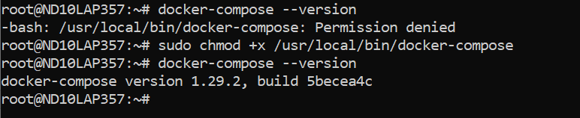

1. For docker to auto start every time you start ubuntu (sudo dockerd starts docker)
   1. Add the following to the end of the “.bashrc” file under your home directory as follows:
      1. nano ~/.bashrc or use **vi ~/.bashrc**
      2. # Start Docker daemon automatically when logging in if not running.  
         RUNNING=`ps aux | grep dockerd | grep -v grep`  
         if [ -z "$RUNNING" ]; then  
          sudo dockerd > /dev/null 2>&1 &  
          disown  
         fi

Exit ubuntu console and login-back, docker daemon should be running. This can be checked as below

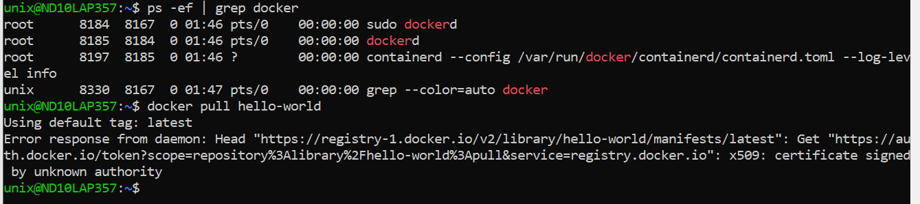

Once the steps above been successfully completed then

1. Login to docker so that it creates a “config.json” with the Artifactory API KEY. You should find the “docker” folder in your “home” folder.

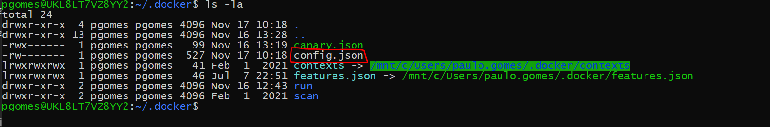

1. Close and start a new shell window and go to the boxed folder
   1. In windows via the mount “/mnt/c/GoToYouBoxedFolder here…” and run Docker as per normal OR
   2. You could git clone boxed in your home directory in Ubuntu
2. If you find that you still need to run linux commands preceded by “sudo” i.e., “sudo docker-compose pull” instead of “docker-compose pull” then run the following:
   1. Create the “docker” group (if it does not exist already) sudo groupadd docker
   2. Add your user to the group: sudo usermod -aG docker $USER
   3. Log out of your session completely. Then start a new WSL session.
   4. Activate the group change by running: newgrp docker
   5. Then try running the docker commands again without “sudo” in front of them.

References

1. <https://medium.com/geekculture/run-docker-in-windows-10-11-wsl-without-docker-desktop-a2a7eb90556d>
2. <https://phoenixnap.com/kb/install-docker-compose-on-ubuntu-20-04>
3. <https://docs.docker.com/engine/install/linux-postinstall/>

# Commands

## docker version

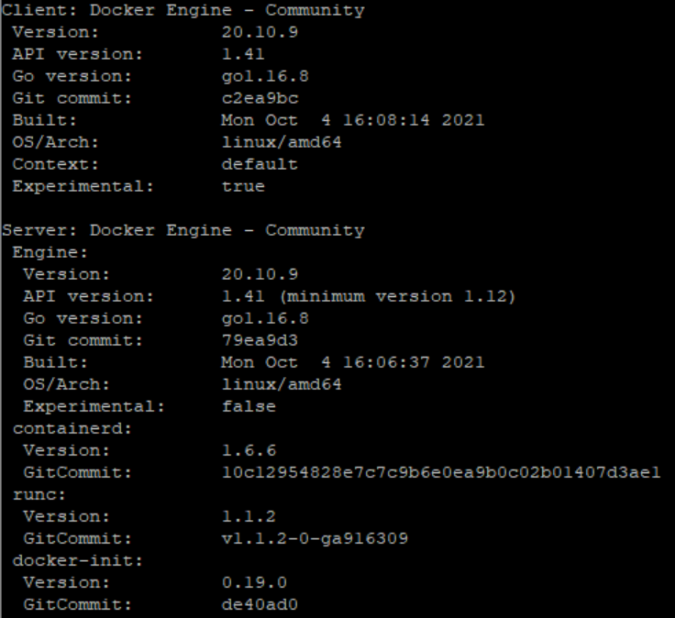

## docker info

This command can be used to see more information about Docker running on the system. This can be used to find following important details

* Number of containers
* Number of images
* The storage driver used by Docker
* The root directory used by Docker
* The execution driver used by Docker

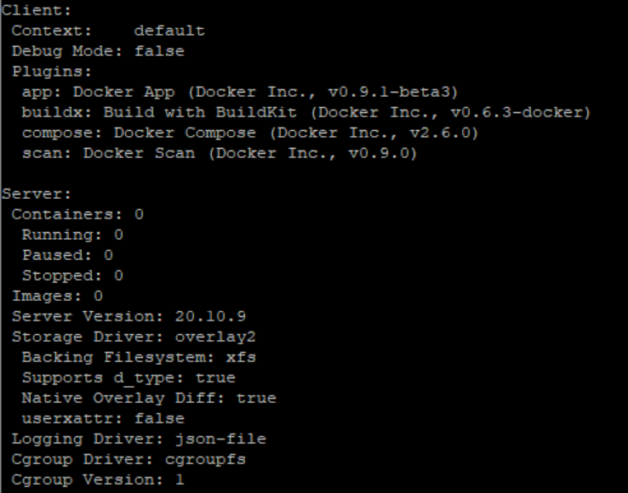

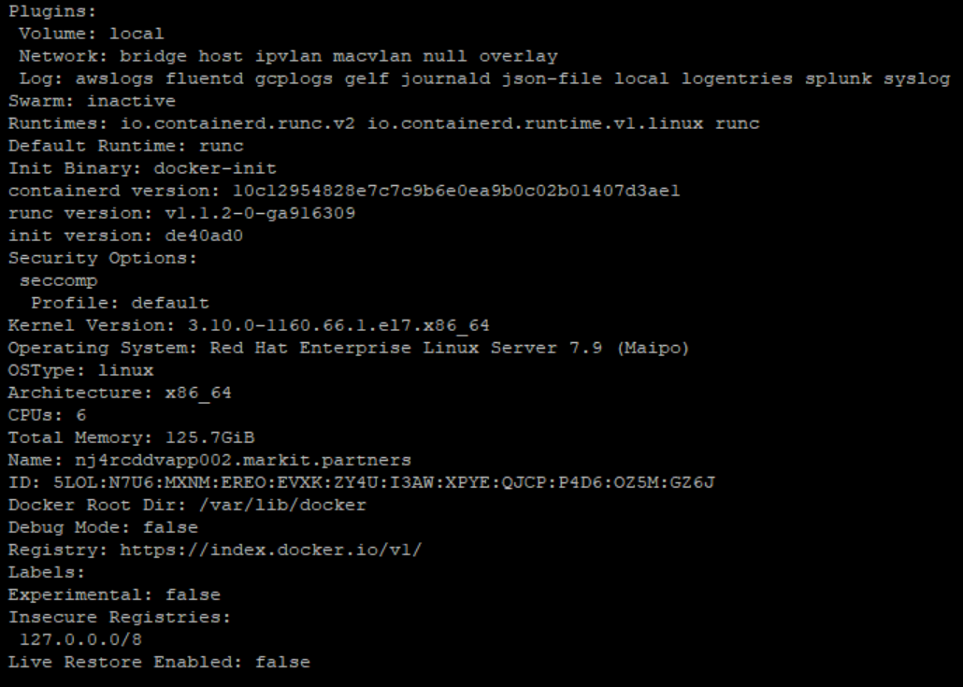

## systemctl commands

systemctl status docker

systemctl start docker

systemctl stop docker

systemctl restart docker

## docker image

To see the list of Docker images on the system, we can issue this command.

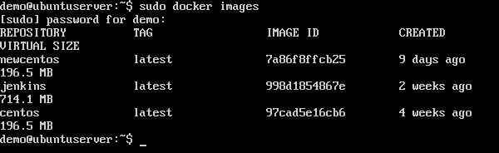

Each image has the following attributes −

* **TAG** − This is used to logically tag images.
* **Image ID** − This is used to uniquely identify the image.
* **Created** − The number of days since the image was created.
* **Virtual Size** − The size of the image.

## docker pull

Above command is used to pull any image from docker hub. For example

$ docker pull jenkins

Now above command will download jenkins image from docker hub and install in our machine. Now we can use run command to run Jenkins

$ docker run -p 8080:8080 -p 50000:50000 jenkins

Given below command will pull the hello-world image from docker hub as shown below:-

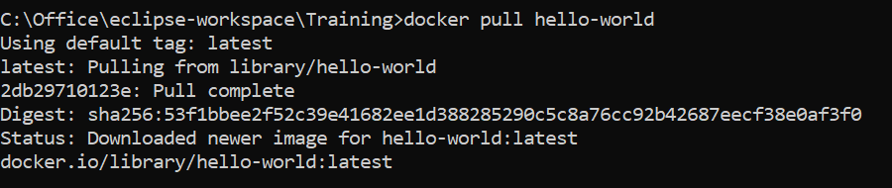

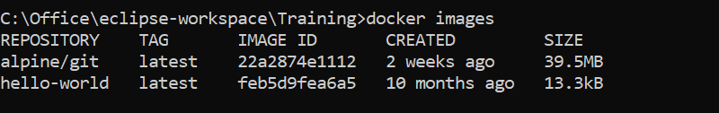

## docker run

This command is used to run a command in a Docker container. After execution of run command, an instance of image will be created.

Docker run **image**

In above command image is the name of the image, which is used to run container.



Example

$ **docker run hello-world**

Above command will download the hello-world image from docker hub and run the hello-world as a container.

-p is used to map the port number of the internal Docker image to our main server, so that we can access the container accordingly. Example

$ docker run -p 8080:8080 -p 50000:50000 jenkins

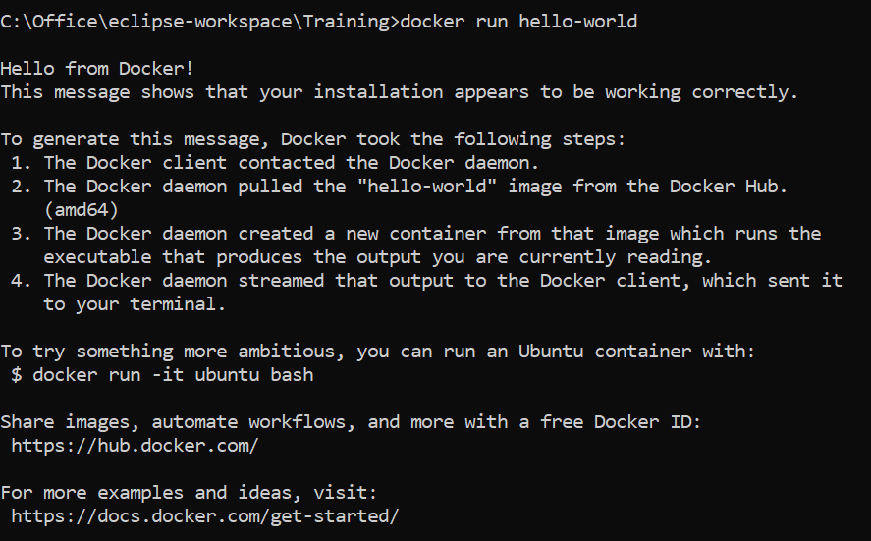

## docker rmi

Docker images on the system can be removed via the **docker rmi** command

**$ *docker rmi < ImageID>***

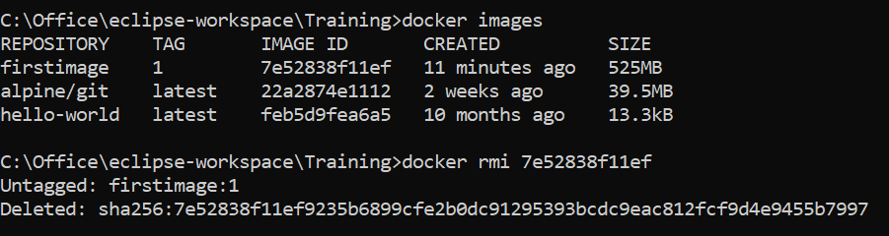

This command can also be used to delete a container

**$ *docker rmi < ContainerID>***

## docker inspect

This command is used see the details of an image or container.

## docker ps

This command can be used for listing of all containers.

$ docker ps

$ docker ps -a

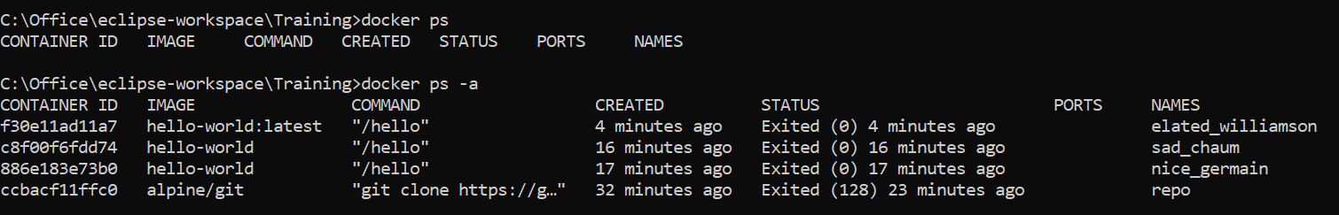

## docker history

This command allows us to see, all the commands that were run with an image via a container.

$ docker history ImageID

## docker stop

This command is used to stop a running container.

$ docker stop ContainerID

## docker top

With this command, you can see the top processes within a container.

$ docker top ContainerID

## docker stats

This command is used to provide the statistics of a running container.

$ docker stats ContainerID

## docker attach

## docker pause

## docker unpause

## docker kill

# Docker file

A docker also gives us the capability to create our own Docker images, and it can be done with the help of **Docker Files**. A Docker File is a simple text file with instructions on how to build our images. Docker builds images automatically by reading the instructions from the Dockerfile. Sample dockerfile is shown below:-

#This is a sample Image – This section is for **comments**

**FROM** ubuntu

**MAINTAINER** demousr@gmail.com

**RUN** apt-get update

**RUN** apt-get install –y nginx

**CMD** [“echo”,”Image created”]

## Dockerfile Instructions

The instructions are not case-sensitive, but you **must follow conventions** which **recommend to use uppercase**. Docker runs instructions of Dockerfile in top to bottom order. The first instruction must be **FROM** to specify the Base Image.

**FROM keyword**

It tells docker, from which base image we want to base our image from. In our example, we are creating an image from the ubuntu image.

**LABEL keyword**

We can add labels to an image to organize images of our project. We need to use LABEL instruction to set label for the image.

**MAINTAINER keyword**

The next command is the person who is going to maintain this image. Here we specify the MAINTAINER keyword and just mention the email ID.

**RUN Command**

The RUN command is used to run instructions against the image. In our case, we first update our Ubuntu system and then install the nginx server on our ubuntu image.

**CMD Command**

This is used to execute application by the image.

In above example, this command is used to display a message to the user.

**COPY Command**

This instruction is used to copy new files or directories from source to the filesystem of the container at the destination.

**WORKDIR**

The WORKDIR is used to set the working directory for any RUN, CMD and COPY instruction that follows it in the Dockerfile. If work directory does not exist, it will be created by default.

**Docker build**

Now our docker file is ready, we need to build or create image out of docker file using the **“docker build”** command. Syntax

$ docker build -t ImageName:TagName dir

* **-t** − is to mention a tag to the image
* **ImageName** − This is the name we want to give to our image.
* **TagName** − This is the tag we want to give to our image.
* **Dir** − The directory where the Docker File is present.

Example

$ docker build -t firstimage:1 .

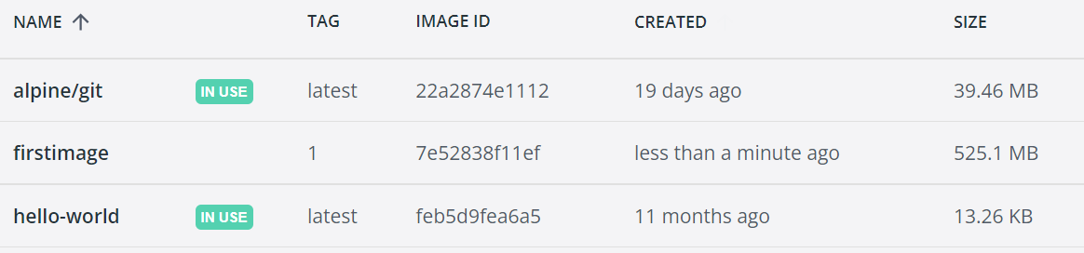

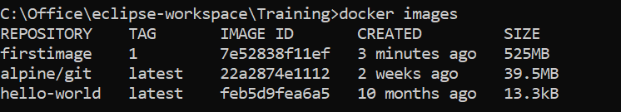

# Dockerizing Spring Boot Applications

## Step1: Create SpringBoot application

Add simple @RestController

@RestController

**public** **class** DockerMessageController

{

@GetMapping("/messages")

**public** String getMessage()

{

**return** "Hello from Docker!";

}

}

Don’t forget to create executable jar by adding following plugins in pom.xml

<build>

<plugins>

<plugin>

<groupId>org.springframework.boot</groupId>

<artifactId>spring-boot-maven-plugin</artifactId>

</plugin>

</plugins>

</build>

Complete pom.xml

<project xmlns=*"http://maven.apache.org/POM/4.0.0"* xmlns:xsi=*"http://www.w3.org/2001/XMLSchema-instance"* xsi:schemaLocation=*"http://maven.apache.org/POM/4.0.0 https://maven.apache.org/xsd/maven-4.0.0.xsd"*>

<modelVersion>4.0.0</modelVersion>

<groupId>com.learning</groupId>

<artifactId>javaDocker</artifactId>

<version>1</version>

<parent>

<groupId>org.springframework.boot</groupId>

<artifactId>spring-boot-starter-parent</artifactId>

<version>2.6.10</version>

<relativePath/>

</parent>

<dependencies>

<dependency>

<groupId>org.springframework.boot</groupId>

<artifactId>spring-boot-starter-web</artifactId>

</dependency>

</dependencies>

<build>

<plugins>

<plugin>

<groupId>org.springframework.boot</groupId>

<artifactId>spring-boot-maven-plugin</artifactId>

</plugin>

</plugins>

</build>

</project>

Run **mvn clean install** which will create executable jar in /target folder

Now **test application** by running following command. SpringBoot application should start

java -jar target/javaDocker-1.jar

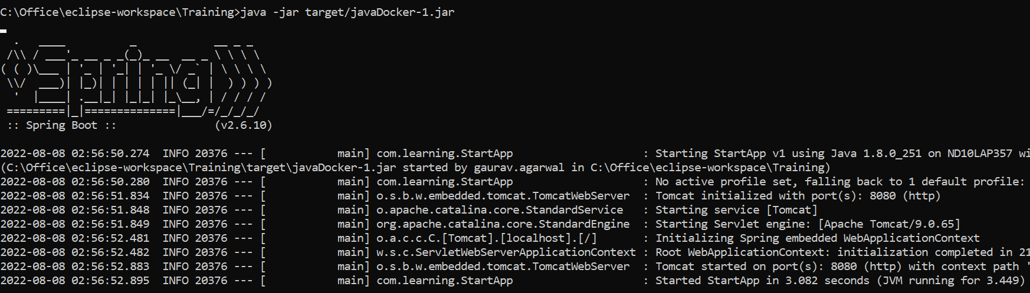

Test application from UI also -> <http://localhost:8080/messages>

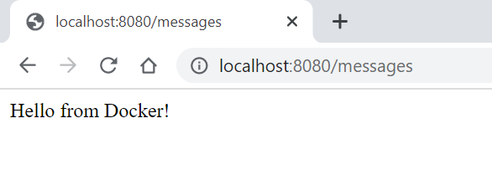

## Step 2: Create Dockerfile

**FROM** openjdk:8-jdk-alpine

**MAINTAINER** learning.com

**COPY** target/javaDocker-1.jar javaDocker-1.jar

**ENTRYPOINT** ["java","-jar","/javaDocker-1.jar"]

This Dockerfile **builds an image** based **on** the image “*openjdk:8-jdk-alpine*” **from Docker Hub**.

## Step 3: Build docker image

Now next step is to create docker image using above Dockerfile. We will use **docker build** command to create the new docker image. We should run the command where Dockerfile is present.

docker build -t firstimage:latest .

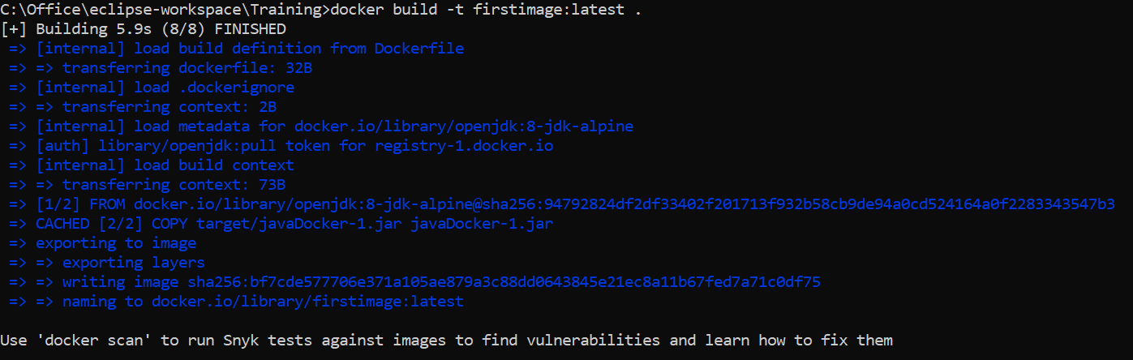

Can use docker images command to check the details of newly created docker image.

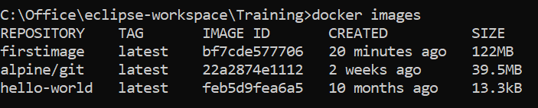

## Step 4: Run docker image

We will use below docker run command to execute the newly created docker image. This will start our application in Docker, and we can access it from the host machine at ***localhost:8887****/messages*. 8080 is the default port used inside the docker by SpringBoot application.

docker run -p8887:8080 firstimage:latest

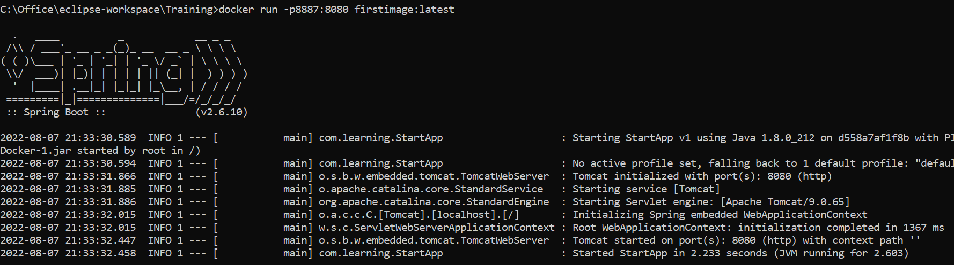

Verify application from UI

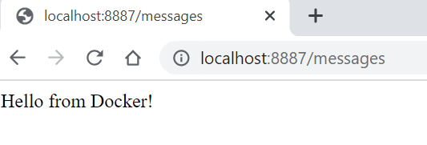

## Docker Desktop

**List of all Images**

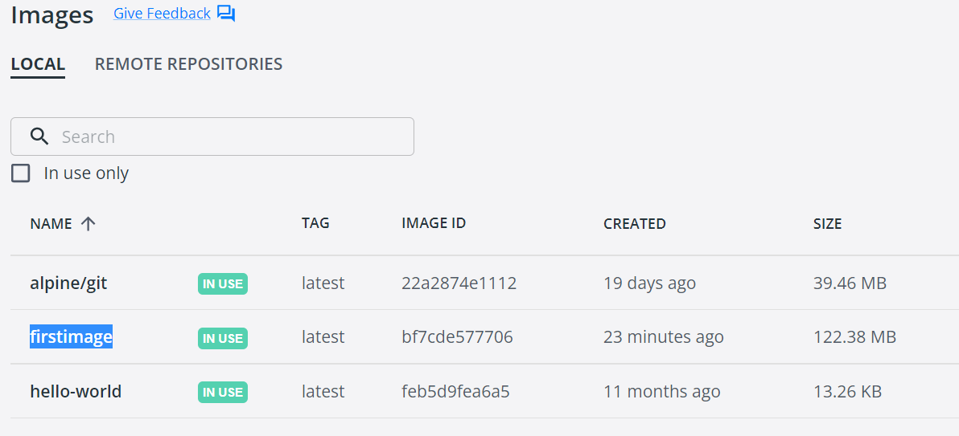

**List of all Containers**

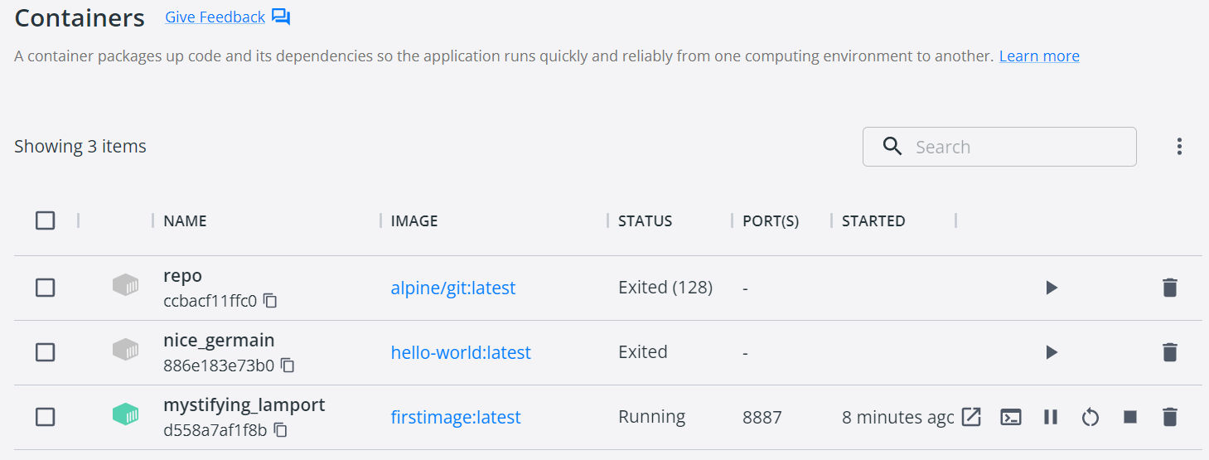

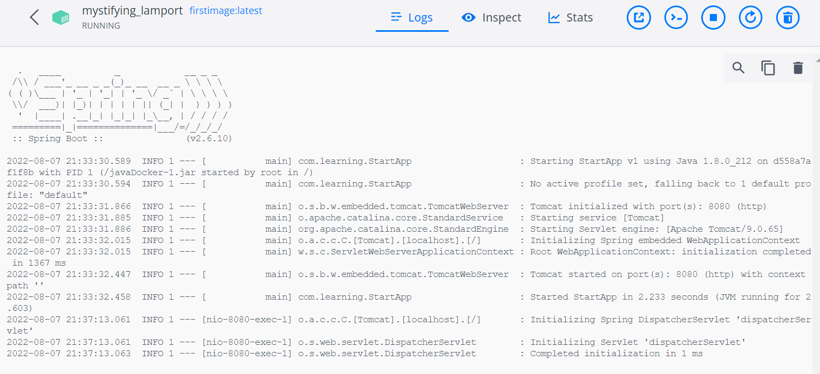

# Docker Image

**What is a Docker Image?**

Think of a Docker image as a read-only template with instructions for creating a Docker container. It's like a snapshot of an application and its dependencies at a specific point in time. It packages everything needed to run the application, including code, runtime, system tools, system libraries, and settings.

**How Docker Images Work**

Docker images are layered. Each layer represents a change to the image. This layered approach makes images efficient and allows for sharing common layers between different images.

## Building Your First Docker Image

Create a simple Docker image with a Node.js application.

### Prerequisites:

* Docker installed on your system
* A basic understanding of Node.js and npm

### Steps:

#### Create a Node.js application:

* Create a new directory for your project.
* Initialize a Node.js project using npm init -y.
* Create an app.js file with a simple Node.js server:

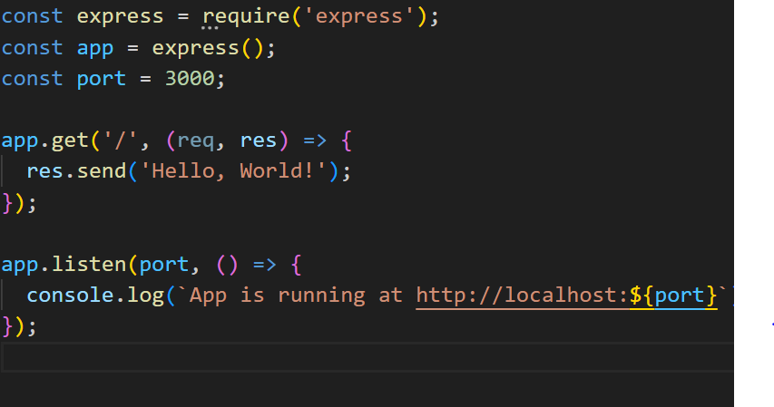

#### Create a Dockerfile:

* Create a file named Dockerfile in your project directory.
* Add the following content to the Dockerfile:

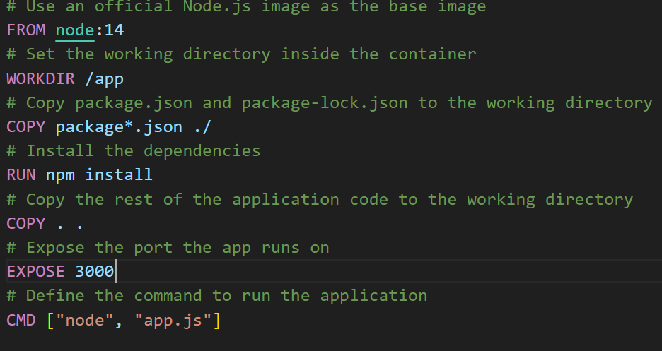

#### Build the Docker image:

* Open a terminal in your project directory.
* Run the following command to build the image:



This command creates a Docker image named my-express-app based on the Dockerfile.

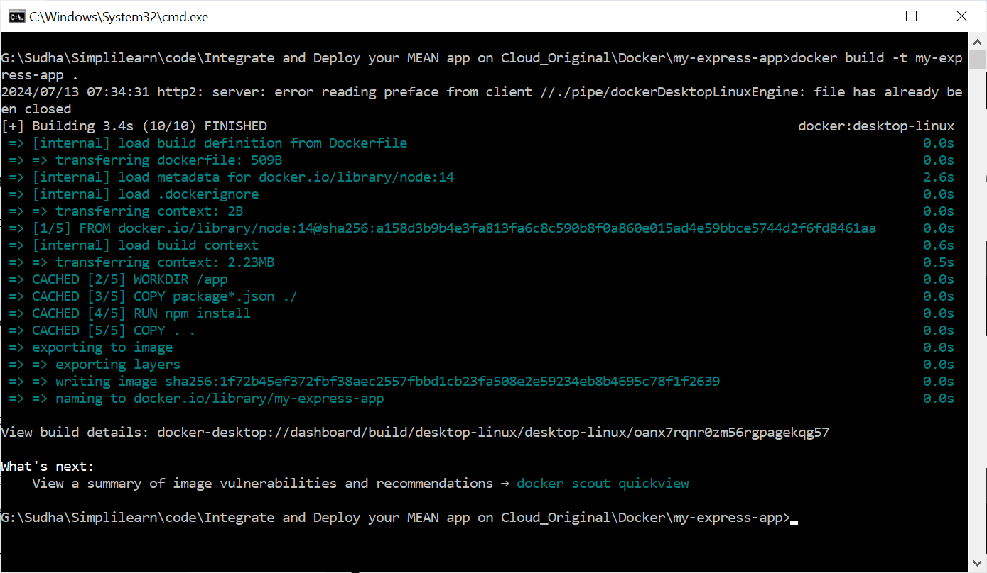

#### Running the Docker Image

Once the image is built, you can run it as a container:



This command starts a container based on the my-express-app image and maps port 3000 on the host to port 3000 inside the container.

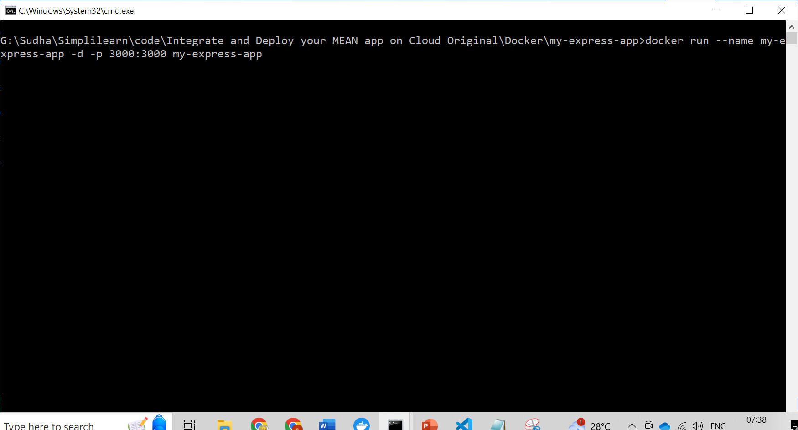

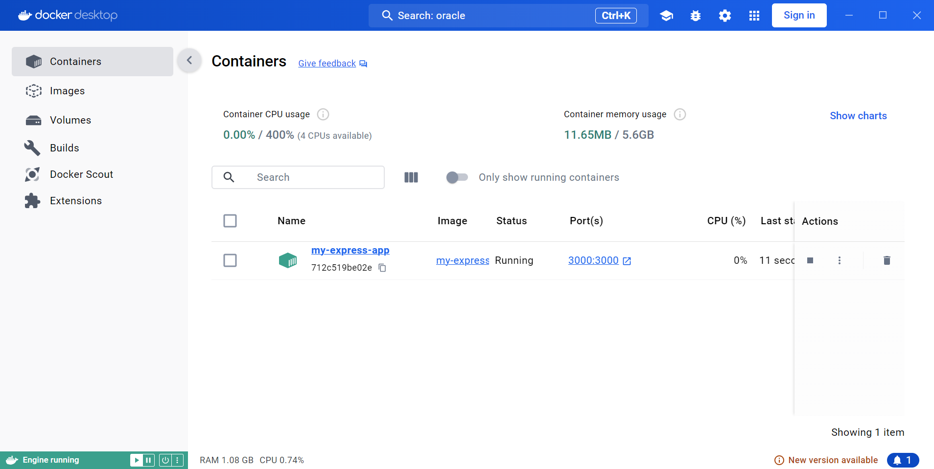

#### Access the Application

Open a web browser and navigate to **http://localhost:3000.** You should see "Hello, World!" displayed on the page.

## Difference between Base Image and Parent Image

| Feature | Base Image | Parent Image |
| --- | --- | --- |
| Definition | The foundational image with no pre-existing layers. It's the starting point for building a Docker image. | An image that is derived from another image (the base image or another parent image). It inherits the layers from its parent. |
| Relationship | No parent image | Can have multiple child images |
| Typical Use Cases | Creating custom base images, building from scratch for specific requirements. | Building application-specific images, leveraging pre-built functionalities. |
| Code Example | FROM scratch | FROM ubuntu:latest |
| Layer Structure | No layers | Multiple layers on top of the base image |
| Image Size | Typically smaller | Usually larger due to additional layers |

### Code Examples

#### Base Image (FROM scratch):

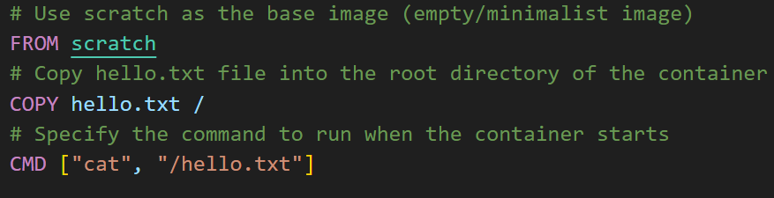

#### Parent Image (FROM ubuntu:latest):

Dockerfile

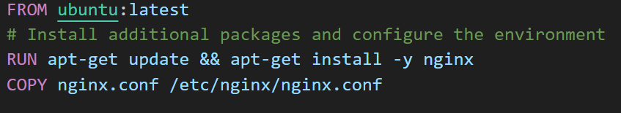

### Key Points:

* **Base images** provide a clean slate for building Docker images from the ground up. They are often used for creating custom base images tailored to specific needs or minimizing image size.
* **Parent images** offer a pre-built foundation with specific functionalities. They are commonly used for building application-specific images, leveraging the base image's package management, system configuration, and other features.

## Tagging a Docker Image

In Docker, a **tag** is a label that you can apply to a Docker image to identify a specific version of that image. Tags help in managing and organizing images, making it easier to reference, share, and deploy them. By default, **Docker assigns the latest tag to images if no other tag is specified.**

### Why Tags are Used:

#### Version Control:

* Tags allow you to version your Docker images. This is crucial for development and production environments where you need to ensure consistency and traceability of the software being deployed.
* Example: You might tag an image as v1.0.0 for the initial release and v1.0.1 for a minor update.

#### Environment Differentiation:

* Tags can help differentiate between images intended for different environments, such as development, staging, and production.
* Example: my-app:dev, my-app:staging, my-app:prod.

#### Rollbacks and Updates:

* If an update introduces a bug, you can easily roll back to a previous tagged version.
* Example: If my-app:v1.0.1 is problematic, you can switch back to my-app:v1.0.0.

#### Parallel Development:

* When multiple features are being developed simultaneously, tags can help manage different versions of the image.
* Example: my-app:feature-a, my-app:feature-b.

### Tagging a Docker Image:

When building a Docker image, you can specify a tag using the -t flag followed by the image name and tag in the format **name:tag**.

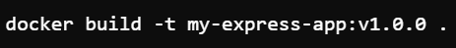

# Dockerizing on AWS

* **Dockerize your application**
* **Build your Docker image**

docker build -t $REPONAME:$version .

docker build -t product/projectname:2.16.3-RELEASE .

* **Login to AWS ECR**

aws ecr get-login-password --region ${AWS_DEFAULT_REGION} | **docker login** --username AWS --password-stdin $AWS_ACCOUNT_NO.dkr.ecr.${AWS_DEFAULT_REGION}.amazonaws.com

* **Tag your image for AWS**

docker tag product/projectname:2.16.3-RELEASE <AccountId>.dkr.ecr.eu-west-1.amazonaws.com/product:projectname-2.16.3-RELEASE

* **Push your image to AWS**

docker push $AWS_ACCOUNT_NO.dkr.ecr.${AWS_DEFAULT_REGION}.amazonaws.com/$**REPONAME**:$**version**

#push docker images to ECR

.push_image:

image: docker-registry-eu.mdevlab.com/images/refdata-java-python-builder:master

before_script:

- *before_script

script:

- version=`cat VERSION`

- **docker build** -t $REPONAME:$version .

- **aws ecr** get-login-password --region ${AWS_DEFAULT_REGION} | docker login --username AWS --password-stdin $AWS_ACCOUNT_NO.dkr.ecr.${AWS_DEFAULT_REGION}.amazonaws.com

- **docker tag** $REPONAME:$version $AWS_ACCOUNT_NO.dkr.ecr.${AWS_DEFAULT_REGION}.amazonaws.com/$REPONAME:$version

- docker push $AWS_ACCOUNT_NO.dkr.ecr.${AWS_DEFAULT_REGION}.amazonaws.com/$REPONAME:$version

# Important Links

<https://rominirani.com/docker-tutorial-series-a7e6ff90a023>

Dockerizing SpringBoot application

<https://www.baeldung.com/dockerizing-spring-boot-application#:~:text=Dockerize%20a%20Standalone%20Spring%20Boot%20Application&text=This%20file%20contains%20the%20following,jar%20file%20into%20the%20image>.

<https://confluence.ihsmarkit.com/display/MNT/Setting+up+Docker+locally+on+WSL+without+Docker+Desktop>

<https://confluence.ihsmarkit.com/display/AT/Docker+Desktop+alternatives+and+directions+to+use>

<https://confluence.ihsmarkit.com/display/AT/Dockerization+Solutioning>

<https://confluence.ihsmarkit.com/display/EM/How+to+pull+Artifactory+docker+images+locally>